MULTI-HYPERVISOR MANAGEMENT: HOW SYSTEM CENTER 2012 MANAGES VMWARE ENVIRONMENTS

Copyright Information

© 2012 Microsoft Corporation. All rights reserved. This document is provided "as-is." Information and views expressed in this document, including URL and other Internet Web site references, may change without notice. You bear the risk of using it. This document does not provide you with any legal rights to any intellectual property in any Microsoft product. You may copy and use this document for your internal, reference purposes. You may modify this document for your internal, reference purposes.

Contents
Topic |  | Page No.
Introduction |  | 4
Business Case for Multi-Hypervisor Management |  | 4
Managing VMware from System Center 2012 |  | 6
 | Scenario I: Configure & deploy your VMware Infrastructure using VMM | 6
 | Scenario II: Automating your VMware Infrastructure using Orchestrator | 8
 | Scenario III: Monitoring your VMware Infrastructure using Operations Manager | 9
Scenario I: Configure & deploy your VMware Infrastructure using VMM

 | STEP 1: How to Add a VMware vCenter Server to VMM | 10
 | STEP 2: How to Add VMware ESX Hosts to VMM | 13
 | STEP 3: How to Import VMware Templates in VMM | 19
 | STEP 4: How to Convert VMware Virtual Machines to Hyper-V Virtual Machines using VMM | 21
 | STEP 5: How to Create a Private Cloud from a VMware Resource Pool | 26
Scenario II: Automating your VMware Infrastructure using Orchestrator

Create a Sample Runbook Using Runbook Designer in Orchestrator |  | 30
Scenario III: Monitoring your VMware Infrastructure using Operations Manager

 | STEP 7: Monitoring VMware Servers using Veeam nWorks Management Pack for System Center Operations Manager | 38
 | STEP 8: VMware Discovery and Monitoring with Bridgeways Management Pack in Operations Manager 2012 RC | 45

Introduction
System Center 2012 helps you manage your IT environments across traditional datacenters, private and public clouds, client computers, and devices. System Center 2012 captures and aggregates knowledge about systems, policies, processes, and best practices so that you can optimize your infrastructure to reduce costs, improve application availability, and enhance service delivery.

One of the unique differentiations for System Center 2012 is the ability to deliver flexible and cost-effective infrastructure using what you already own. System Center 2012 enables this by
- Managing different hypervisors centrally from a single pane of glass with support for Windows Server Hyper-V, VMware vSphere, and Citrix XenServer.
- Monitoring Windows Server, Sun Solaris, and various Linux and Unix distributions.
- Integrating toolsets from HP, CA, BMC, EMC, and VMware into automated workflows.

In this whitepaper, we explore System Center 2012 support for managing VMware environments.

Business Case for Multi-Hypervisor Management
System Center 2012 manages Hyper-V, VMware ESX/ESXi, and Citrix XenServer through a common console allowing you to perform common actions on your heterogeneous environments. When creating private clouds, customers want to leverage their existing infrastructure and diversify their options. A private cloud environment, similar to a public cloud, leverages the concept of fabric computing. Fabric in System Center 2012 is an abstraction to hide the underlying complexities from users and simplify the ability to define and use resources pools. The fabric in System Center 2012 is made up of hosts, host groups and library servers, as well as networking and storage configuration. These hosts can include Hyper-V hosts as well as non-Hyper-V hosts, including VMware ESX/ESXi hosts and Citrix XenServer hosts. This cloud architecture abstracts the underlying infrastructure from users, but lets them deploy VMs, applications and services irrespective of whether the infrastructure is running on Microsoft hypervisor technology or hypervisors from VMware or Citrix.

The ability to manage multiple hypervisors through a common console has the following benefits
- Consistency: you can deploy VMs and applications in a consistent manner and get same capabilities with different hypervisors.
- Choice: you can choose to utilize a mix of hypervisors for your business critical apps, branch offices, or test and development environments. If needed, you can aggregate one or more hypervisors’ host groups into a private cloud without worrying about underlying hypervisor capabilities and limitations.
- Simplicity: abstracting the hypervisor layer reduces complexity and makes it easier to perform common actions on your heterogeneous environments

In a recent survey of VMware and Storage usage, half of the VMware admins indicated that they run Hyper-V as well. The respondents came in from 65 different countries and had a wide range of scale- from 4 VMs to 200,000 VMs. The survey result is shown below.
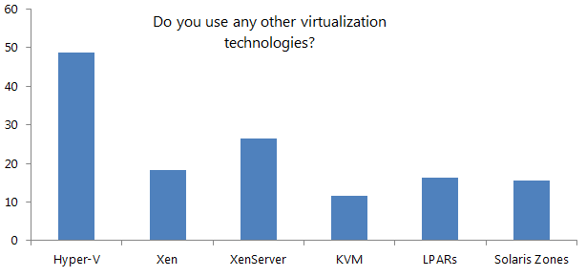

Customers are realizing the tremendous cost savings they can achieve with Hyper-V and System Center while leveraging their existing infrastructure investments in VMware.

Microsoft private cloud solutions are licensed on a per processor basis, so you get the cloud computing benefits of scale with unlimited virtualization and lower costs – consistently and predictably over time. VMware private cloud solutions are licensed by the number of virtual machines and the virtual memory allocated to those virtual machines – charging you more as you grow. This fundamental difference in approach means that with Microsoft your private cloud ROI increases as your private cloud workload density increases. With VMware, your cost grows, as your workload density does, making it increasingly difficult to achieve a predictable cloud growth model. For example, a VMware private cloud can be 15X more expensive than a comparable Microsoft private cloud solution as shown below.
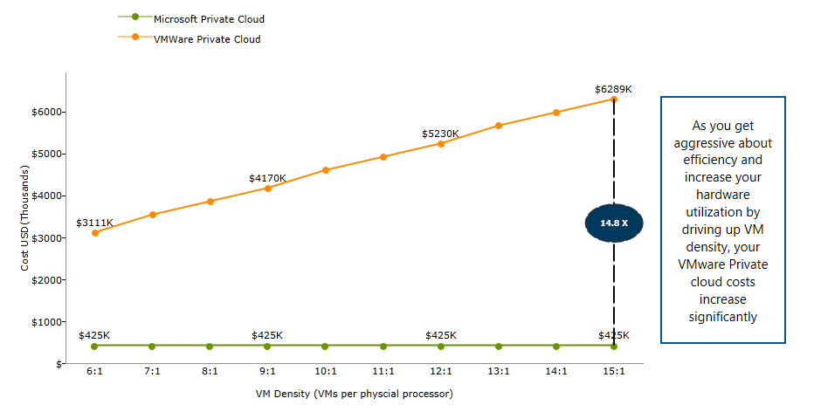
A major portion of VMware private cloud licensing cost is the adjacent technologies to vSphere- vCenter Operations Management Suite, vCenter SRM, vCloud Director etc. If you choose System Center 2012 for your datacenter and private cloud management, you will not only reduce your VMware licensing costs, but will also be able to leverage your existing vSphere investments and still achieve private cloud benefits. This is shown in the graphic below. Adopting a Microsoft based private cloud not only provides you significant cost savings, but you can also leverage your existing VMware investments. An example below clarifies this further.

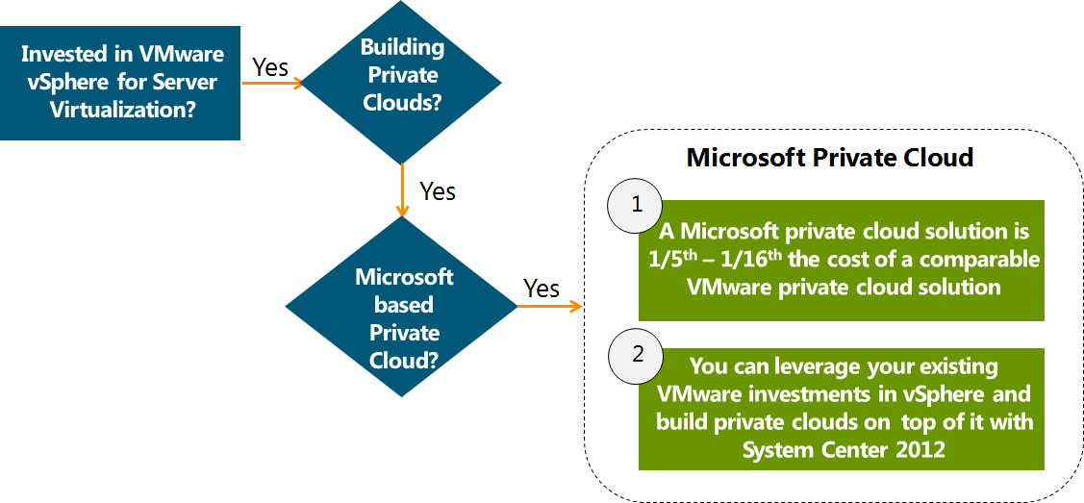

Managing VMware from System Center 2012

System Center 2012, a single product, has 8 components, including Virtual Machine Manager (VMM), Orchestrator, and Operations Manager, which can be used to manage VMware environments in the following way

- System Center 2012 – Virtual Machine Manager (VMM) enables you to deploy and manage virtual machines and services across multiple hypervisor platforms, including VMware ESX and ESXi hosts.
- System Center 2012 - Orchestrator includes over 41 built-in workflow standard activities that perform a wide variety of functions. You can expand Orchestrator’s functionality and ability to integrate with VMware environments by installing a vSphere integration pack. The integration pack for VMware vSphere is an add-on for System Center 2012 - Orchestrator that assists you in automating actions in VMware vSphere, enabling full management of your virtualized computing infrastructure.
- System Center 2012- Operations Manager can be used to monitor VMware environments by using 3rd party management packs like those from Veeam and Bridgeways.

Scenario I: Configure & deploy your VMware Infrastructure using VMM

Virtual Machine Manager (VMM), a component of System Center 2012 is a management solution for the virtualized datacenter, enabling you to configure and manage your virtualization host, networking, and storage resources in order to create and deploy virtual machines and services to private clouds that you have created. In VMM, support for ESX/ESXi is optimized for virtual machine and service management.
VMM has an abstraction layer that lets you plug in multiple hypervisor platforms under it. VMM enables you to manage and provide resources from multiple hypervisors and make the resources available to private cloud deployments, all from a common user interface and common command-line interface (CLI). VMM integrates directly with VMware vCenter Server. Through the VMM console, you can manage the day-to-day operations of VMware ESX/ESXi hosts and host clusters, such as the discovery and management of ESX/ESXi hosts, and the ability to create, manage, store, place and deploy virtual machines on ESX/ESXi hosts. The architecture of VMM is shown below.
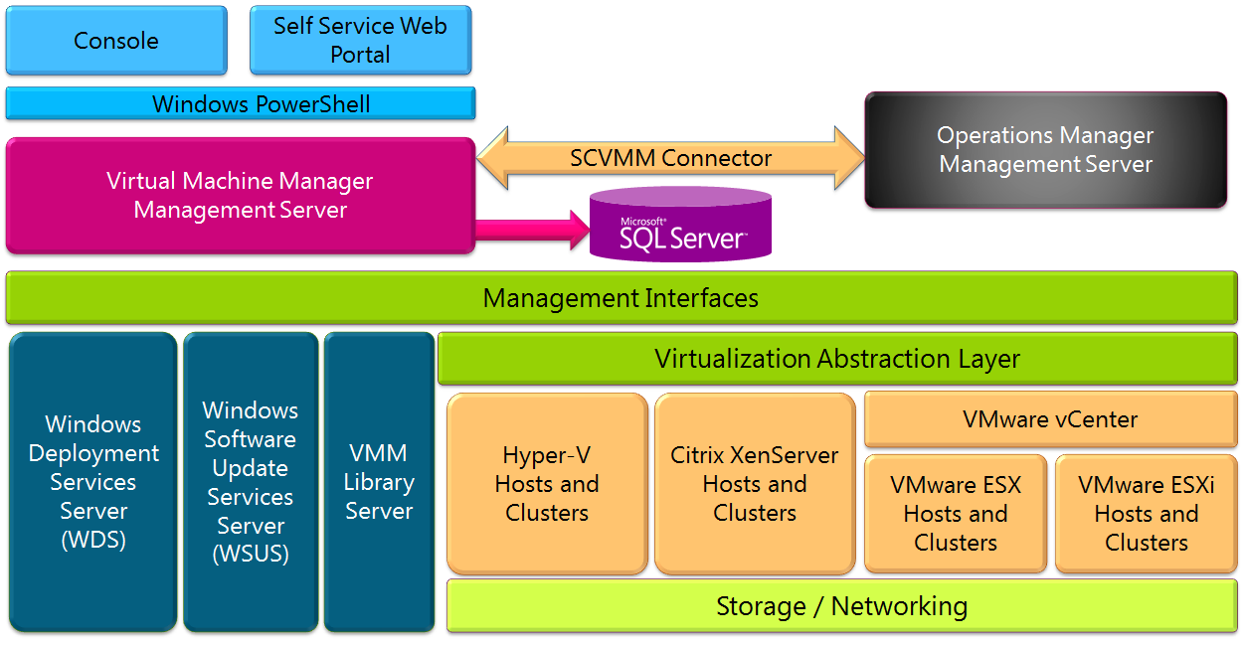

Supported Features – VMM Managing VMware environments
The following table shows some of the VMM and VMware features that are supported when VMM manages ESX/ESXi hosts.

Functionality | Supported by VMM | Notes
Private Clouds |  | You can make ESX/ESXi host resources available to a private cloud by creating private clouds from host groups where ESX/ESXi hosts reside, or by creating a private cloud from a VMware resource pool.
Dynamic Optimization and Power Optimization |  | You can use the new VMM Dynamic Optimization features with ESX hosts. For power optimization, you can use the Dynamic Optimization feature in VMM or the VMware Dynamic Resource Scheduler.
Live Migration |  | live Migrate between hosts within cluster is supported by VMM
Live Storage Migration |  | Live Storage Migration is supported by VMM
Networking |  | VMM recognizes and uses existing configured vSwitches and port groups for virtual machine deployment.
Storage |  | VMM supports and recognizes VMware Paravirtual SCSI (PVSCSI) storage adapters and VMware thin provision virtual hard disks.
VMM Command Shell |  | The VMM command shell is common across all hypervisors
Library |  | You can organize and store VMware virtual machines, .vmdk (VMDK) files, and VMware templates in the VMM library. VMM supports creating new virtual machines from templates and converting stored VMware virtual machines to Hyper-V
The entire list is available here, http://technet.microsoft.com/library/gg610683.aspx

Example
The concept of services is one of the most exciting new aspects of VMM. You can use a service template that contains all the settings for a group of VMs that work together at different tiers to provide users a service. You can deploy the whole service as one unit. If the load on that service increases, you can scale out selected tiers with additional VMs as needed. A service template can be composed with VM templates from multiple different hypervisors giving you the flexibility to put the different tiers of the service on the corresponding virtualized environment.
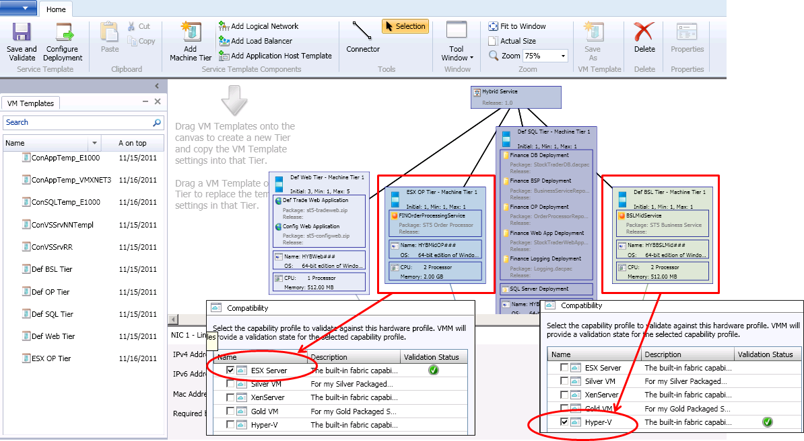

In the example above, the Order Processing Tier is installed on a VMware ESXi host, while the business logic tier is installed on a Hyper-V host. Till now, we discussed how VMM can configure and deploy your private cloud infrastructure by abstracting the hypervisor layer and deploying VMs and applications in a consistent manner using service templates.

Scenario II: Automating your VMware Infrastructure using Orchestrator

The integration pack for VMware vSphere is an add-on for System Center 2012 - Orchestrator that assists you in automating actions in VMware vSphere, enabling full management of your virtualized computing infrastructure. The integration pack includes 29 different activities for VM and host management. The VMware vSphere integration pack adds the vSphere category to the Activities pane in the Runbook Designer as shown below in a sample runbook.
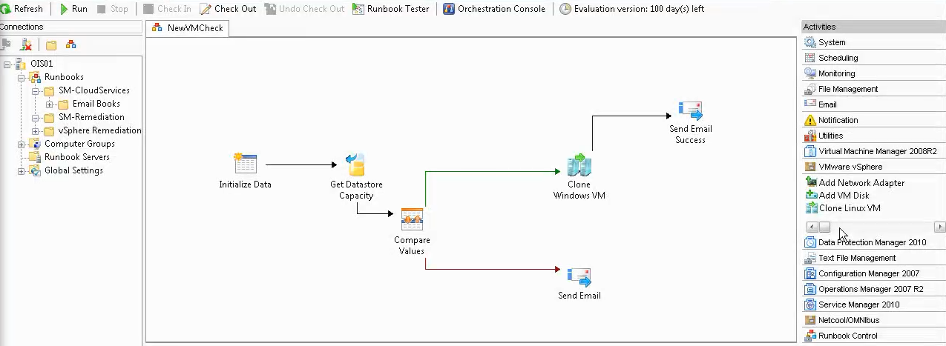

Scenario III: Monitoring your VMware Infrastructure using Operations Manager
An Operations Manager management pack makes it possible to collect and utilize a wide range of information from various sources, including VMware vSphere. Management packs typically contain monitoring settings for applications and services. After a management pack is imported into a management group, Operations Manager immediately begins monitoring objects based on default configurations and thresholds that are set by the management pack. Microsoft partners like Veeam and Bridgeways have created management packs for monitoring VMware environments.

The Veeam nworks management pack is built on System Center so you get complete visibility and seamless management of VMware in Operations Manager as shown below. The nworks management pack leverages and protects the investments you've already made in System Center by bringing VMware into the fold. It preserves the integrity of your unified Operations Manager console and the IT policies and practices you've built around System Center.
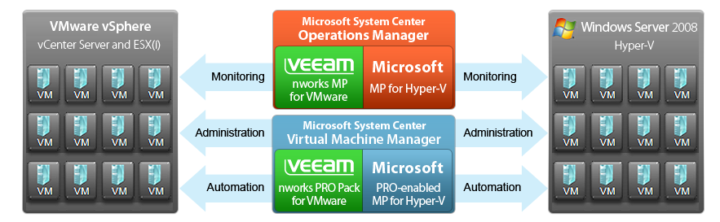

Scenario I: Configure & deploy your VMware Infrastructure using VMM

STEP 1: How to Add a VMware vCenter Server to SCVMM 2012 RC

STEPS | SCREENSHOTS
- Open the Fabric workspace. In the Fabric pane, expand Servers, and then click vCenter Servers. | 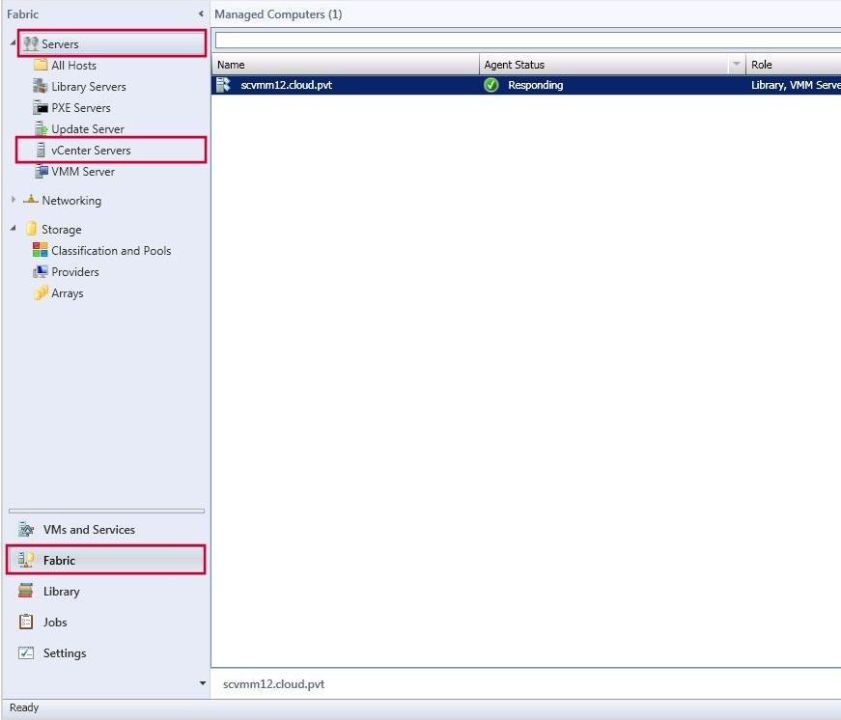
- On the Home tab, in the Add group, click Add Resources, and then click VMware vCenter Server. | 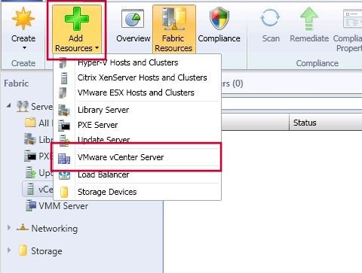
- In the Add VMware vCenter Server dialog box, do the following:  - In the Computer name box, enter the fully qualified domain name (FQDN), NetBIOS name, or IP address of the vCenter Server.  - In the TCP/IP port box, enter the port to use to connect to the vCenter Server. By default, VMM uses TCP/IP port 443 to connect to the server through Secure Socket Layer (SSL).  - Next to the Run As account box, click Browse, click the Run As account that has administrative access to the vCenter Server, and then click OK.  - In the Security area, select or clear the Communicate with VMware ESX hosts in secure mode check box. By default, this check box is selected (recommended). If selected, a certificate and public key are required for each ESX or ESXi host that is managed by the vCenter Server. If you clear the check box, only Run As account credentials are required for communication. When you are finished, click OK. |  | 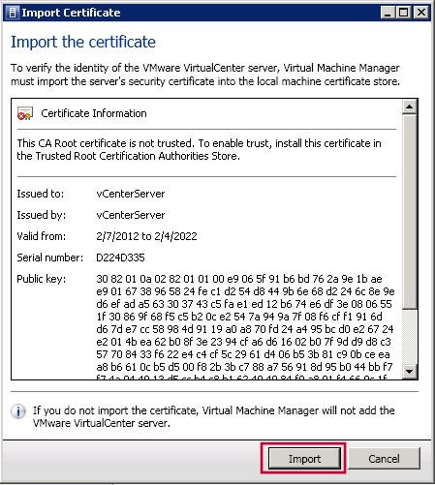
- If you are using a self-signed certificate for the vCenter Server, and you have not manually copied the certificate into the Trusted People certificate store on the VMM management server, the Import Certificate dialog box appears. In the Import Certificatedialog box, review the VMware certificate information, and then click Import to add the certificate to the Trusted People certificate store. |  | 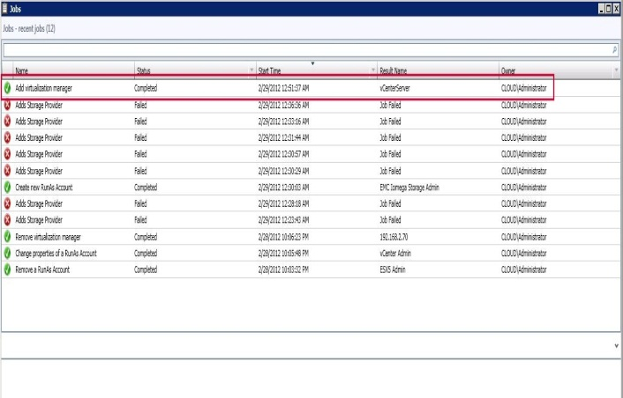
- The Jobs dialog box appears. Make sure that the job to add the vCenter Server has a status of Completed, and then close the dialog box. |  | 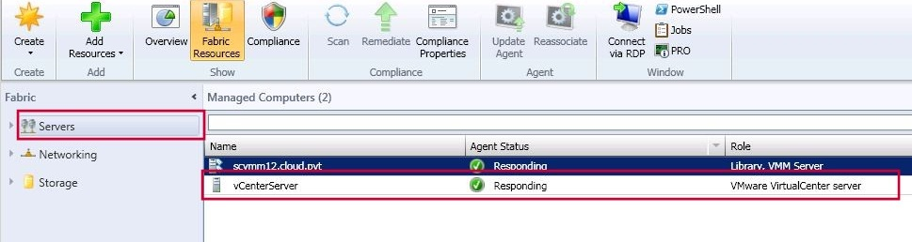

STEP 2: How to Add VMware ESX Hosts to VMM
- Open the Fabric workspace and on the Home tab, in the Add group, click Add Resources, and then click VMware ESX Hosts and Clusters. | 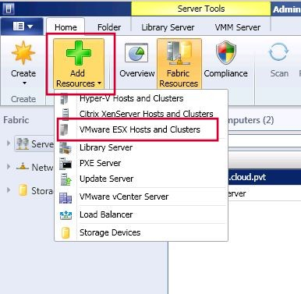
- On the Credentials page, next to the Run As account box, click Browse. | 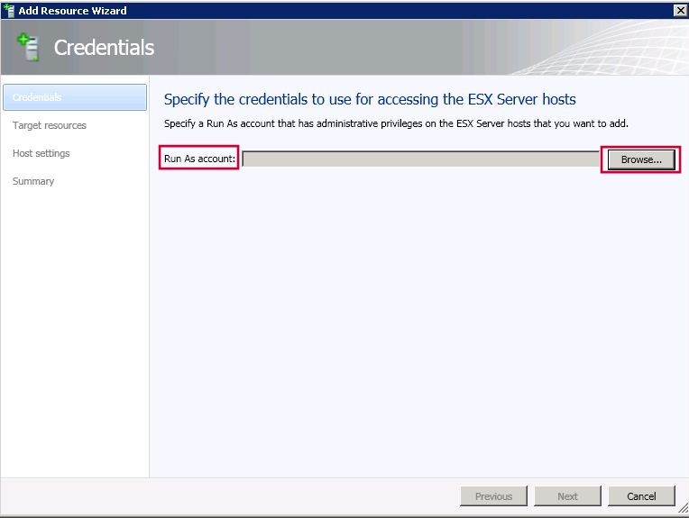
- Click the Run As account that has root credentials on the ESX hosts that you want to add, click OK. For example, if you created the Run As account that is described in the Prerequisites section of this topic, click the ESX4 Admin Run As account. | 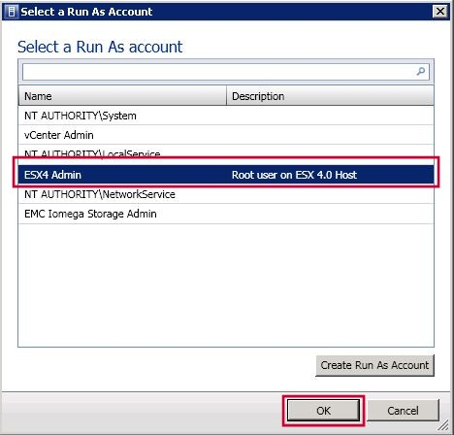
- Click Next. | 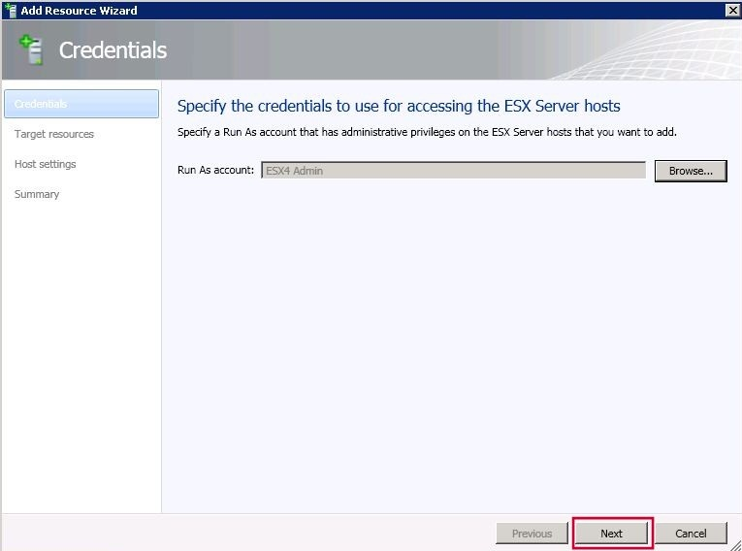
- On the Target resources page, in the VMware vCenter Server list, click the vCenter Server that manages the ESX hosts that you want to add. The available ESX hosts for the selected vCenter Server are listed. If the ESX hosts are clustered, the cluster name is listed together with the cluster nodes. | 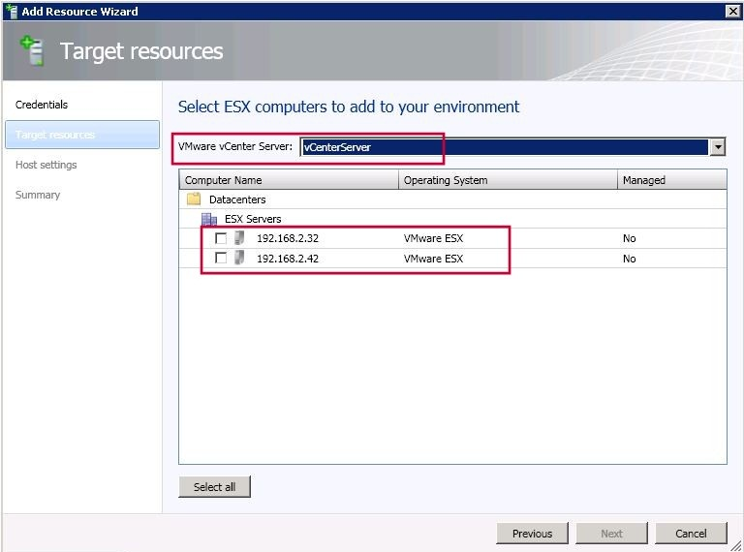
- In the Computer Name column, select the check box next to each ESX host or host cluster that you want to add, or click Select all. When you are finished, click Next. | 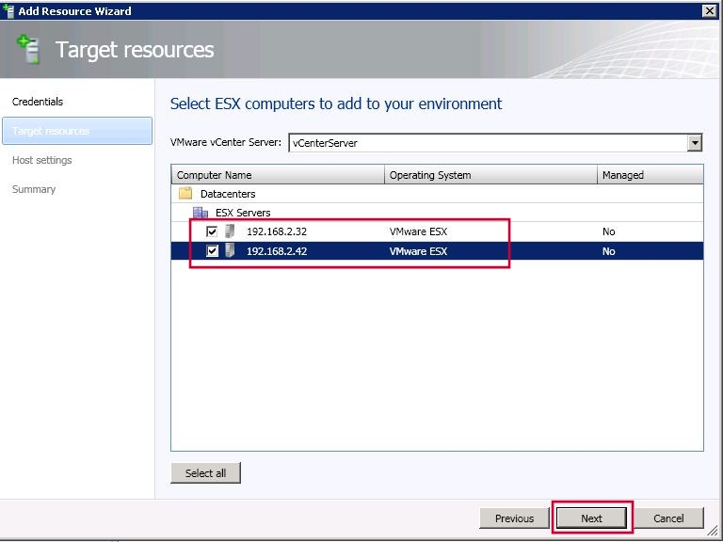
- On the Host settings page, in the Location list, click the host group where you want to assign the ESX hosts, and then click Next. | 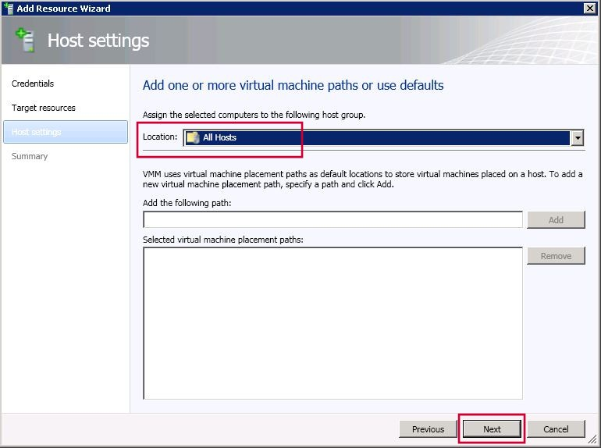
- On the Summary page, confirm the settings, and then click Finish. | 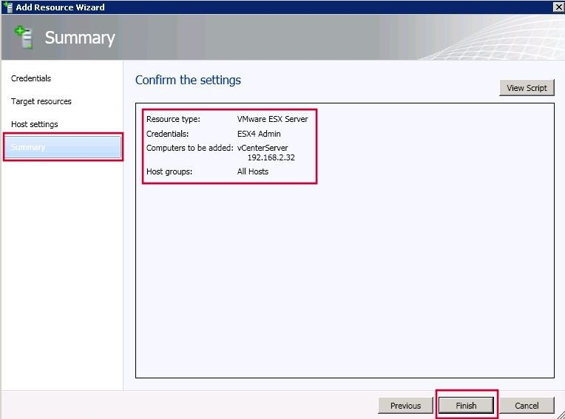
- The Jobs dialog box opens to indicate the job status. Verify that the job has a status of Completed, and then close the dialog box. | 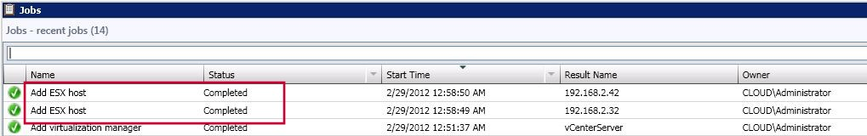
- To verify that the ESX host or host cluster was added, in the Fabric workspace, expand Servers, expand All Hosts, and then expand the host group where you added the ESX host or host cluster. Click the host or host cluster, and then verify in the Hosts pane that each host has a status of either OK or OK (Limited). If each host has a status of OK, you do not have to complete the rest of this procedure. | 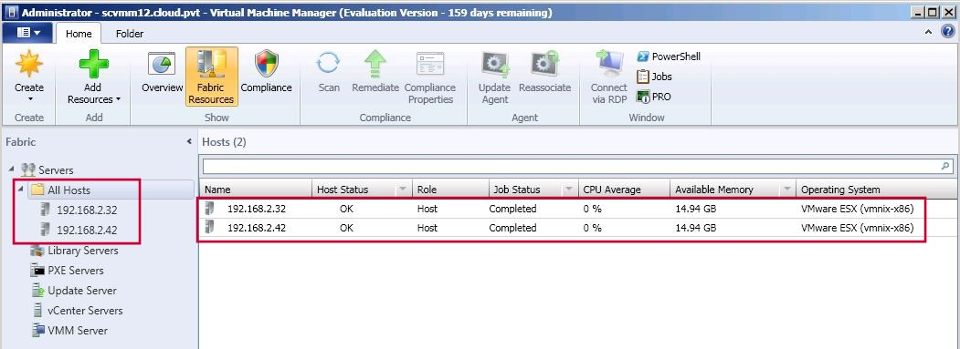
- If the host status is OK (Limited), you must provide security information for the host to enable all supported management tasks in VMM. The host status indicates OK (Limited) if the Run As account that you specified does not have root credentials, or you enabled secure mode, but have not yet imported a certificate and public key. | 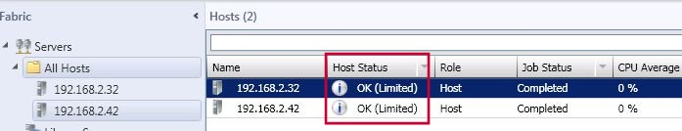
- To update the host status to OK, follow these steps:  - Right-click an ESX host that has a status of OK (Limited), and then click Properties. | 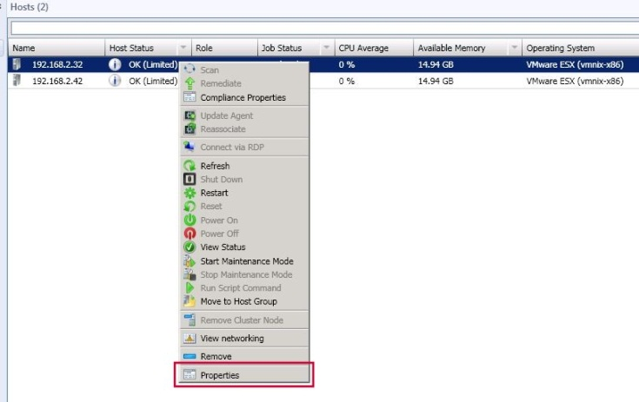
- Host Name Properties dialog box opens. Click the Management tab. | 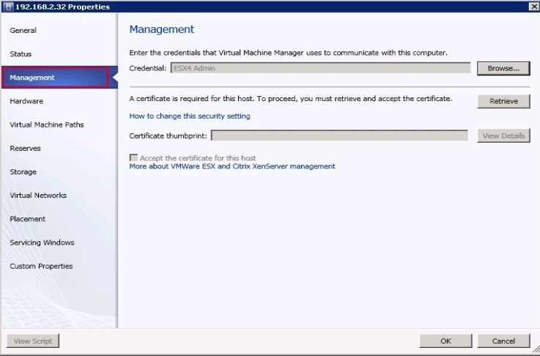
- In the Credential box, verify that the listed Run As account has root credentials on the host. | 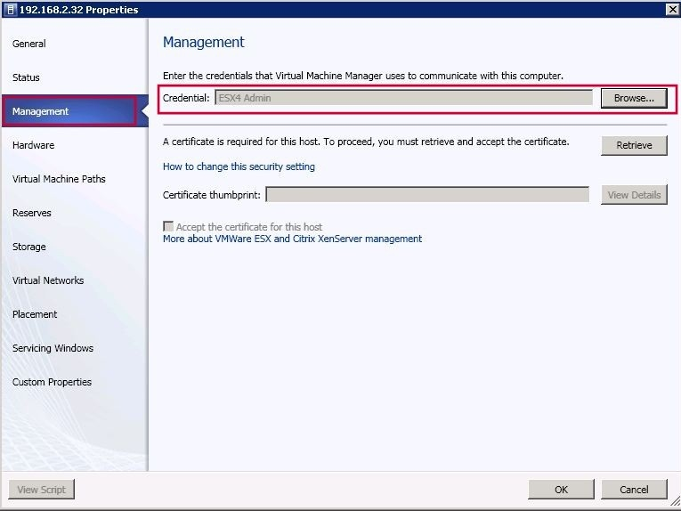
- To retrieve the certificate and public key for the host, click Retrieve. | 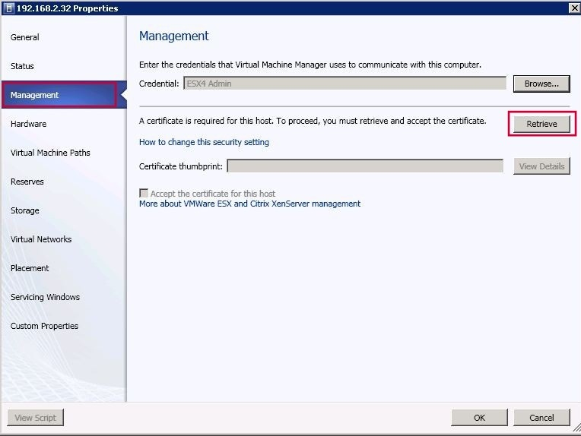
- The certificate thumbprint is retrieved. To view the thumbprint details, click View Details. | 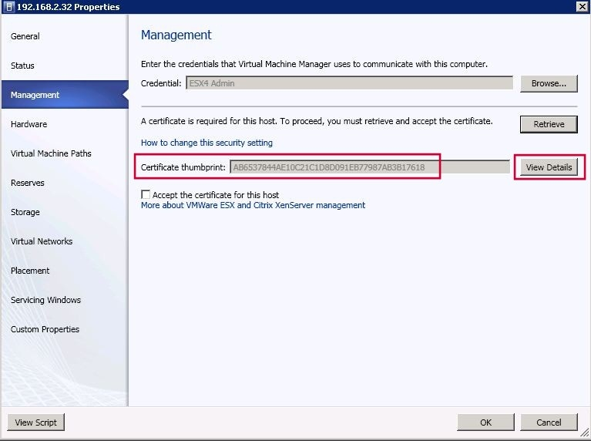
- To accept the certificate and public key, select the Accept the certificate for this host check box. | 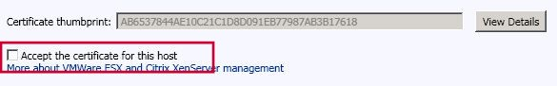
- When you are finished, click OK. | 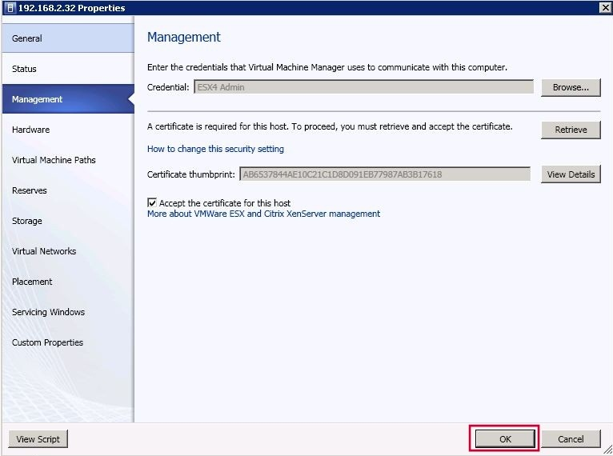
- In the Hosts pane, verify that the host status is OK. | 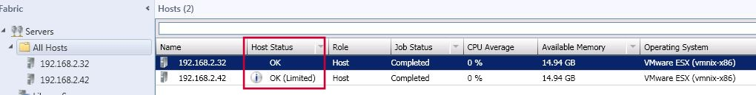
- Repeat step 12 for each host that has a status of OK (Limited). | 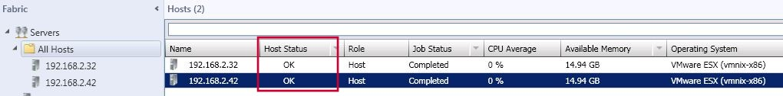

STEP 3: How to Import VMware Templates in SCVMM 2012 RC
When you import a VMware template to the VMM library, the .vmdk file is no longer copied to the library. Instead, VMM only copies the metadata that is associated with the template. Therefore, there is now a dependency on the VMware template on the vCenter Server.
Before you begin this procedure, make sure that the VMware vCenter Server where the template resides is under VMM management.

STEPS | SCREENSHOTS
- Open the Library workspace. | 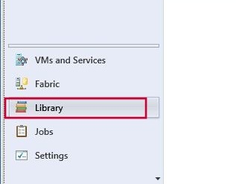
- On the Home tab, in the Import group, click Import VMware Template. | 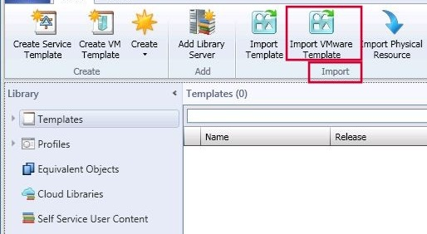
- The Import VMware Templates dialog box opens. Select the check box next to each VMware template that you want to import, and then click OK. | 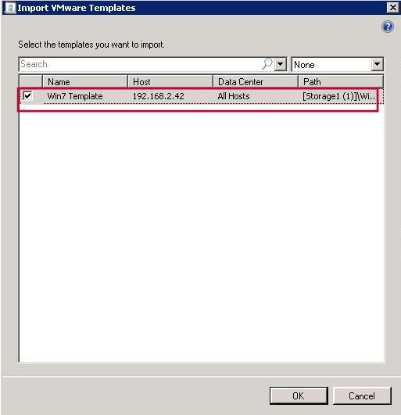
- To verify that the template was added, in the Library pane, expand Templates, and then click VM Templates. In the Templates pane, verify that the template appears. | 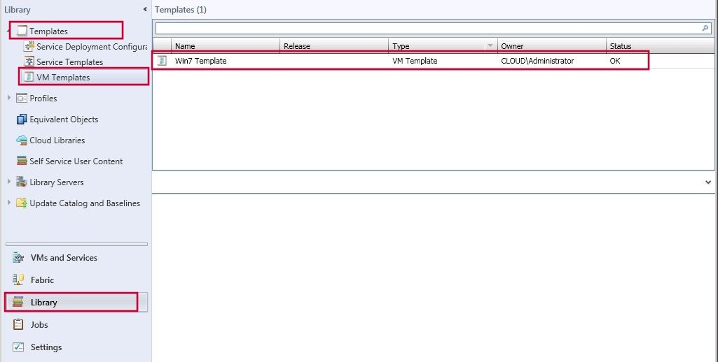

STEP 4: How to Convert VMware Virtual Machines to Hyper-V Virtual Machines using SCVMM 2012RC

STEPS | SCREENSHOTS
- Open the VMs and Services workspace. | 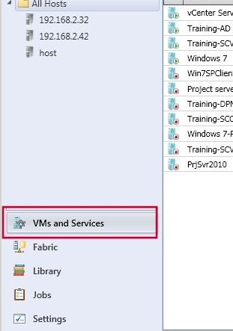
- On the Home tab, in the Create group, click the Create Virtual Machine drop-down arrow, and then click Convert Virtual Machine. | 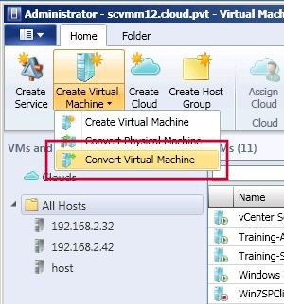
- The Convert Virtual Machine Wizard opens. On the Select Source page, next to the Select the virtual machine that you would like to convert box, click Browse. | 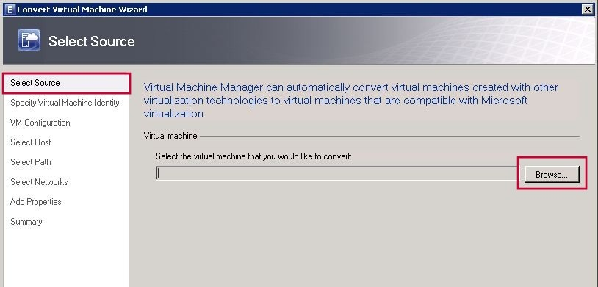
- In the Select Virtual Machine Source dialog box, click the VMware virtual machine that you want to convert, and then click OK. | 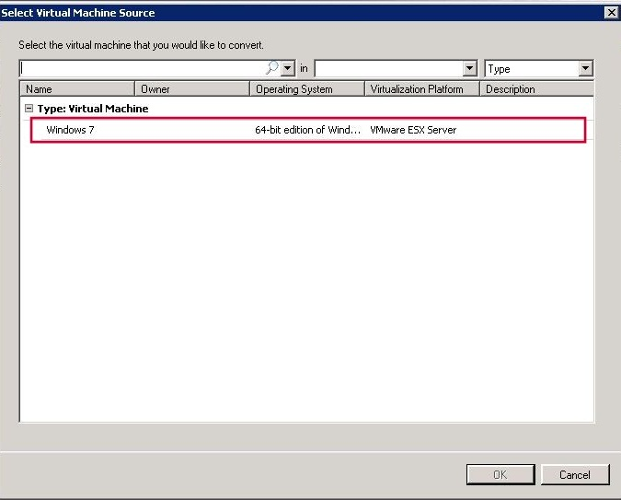
- On the Select Source page, click Next. | 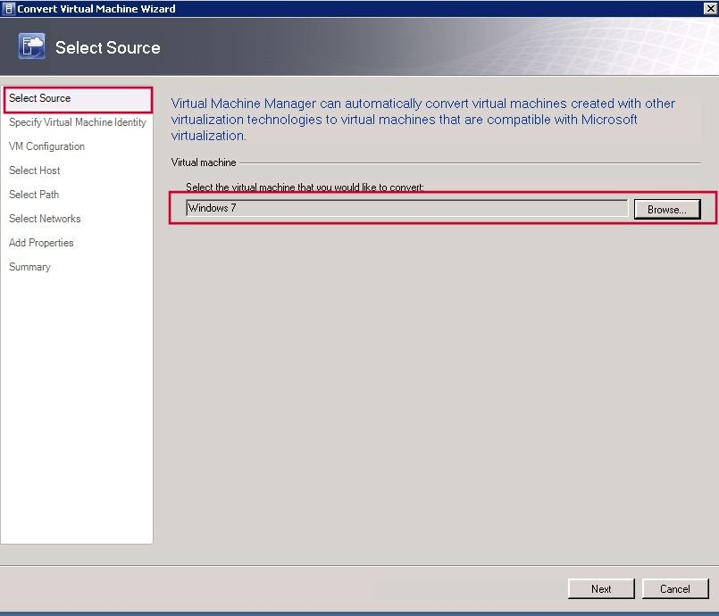
- On the Specify Virtual Machine Identity page, either keep or change the virtual machine name, enter an optional description, and then click Next. | 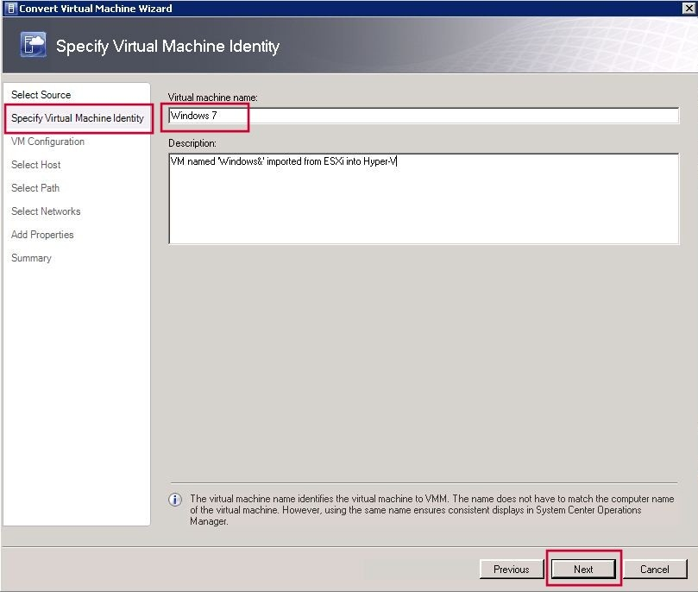
- On the Virtual Machine Configuration page, configure the number of processors and the amount of memory to assign (in megabytes or gigabytes), and then click Next. | 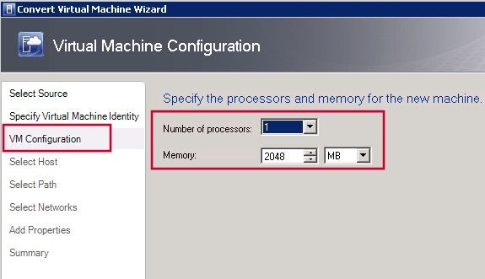
- On the Select Host page, select a Hyper-V host for placement, and then click Next. | 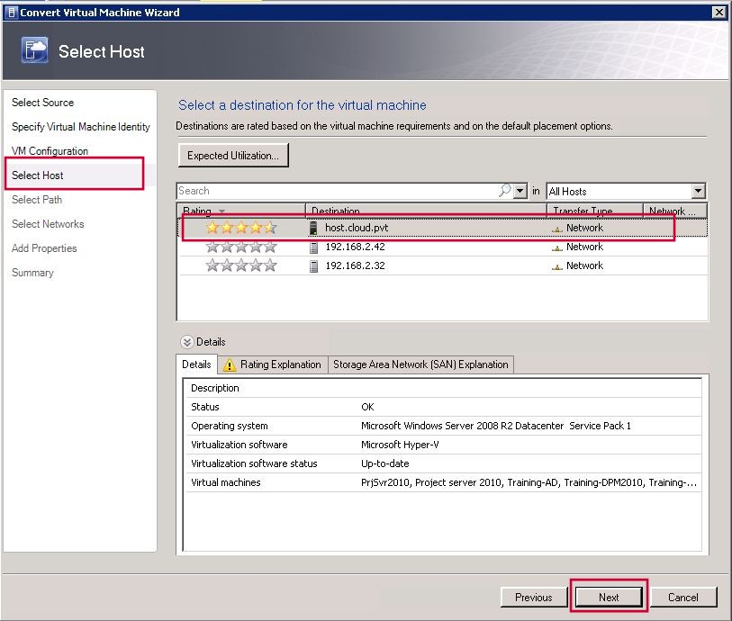
- On the Select Path page, do the following, and then click Next:  - In the Storage location box, configure the storage location on the host for virtual machine files. By default, the default virtual machine paths on the target host are listed. To select a different location, click Browse, click a folder, and then click OK. | 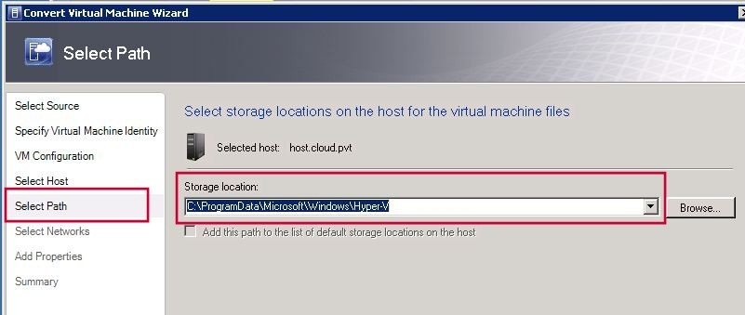
- On the Select Networks page, select the logical network, the virtual network and the VLAN (if applicable) to use for the virtual machine, and then click Next. | 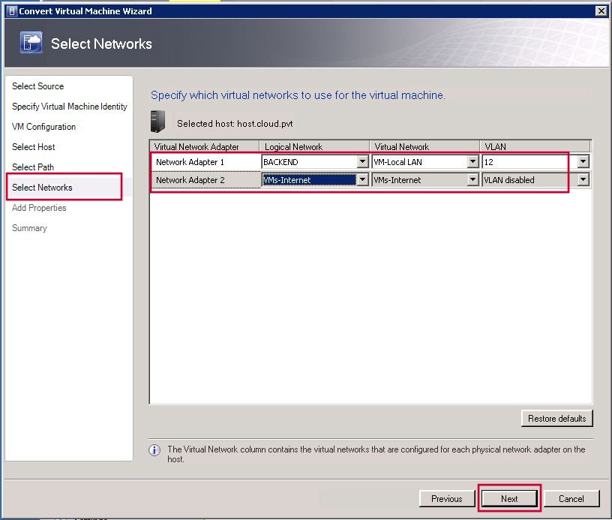
- On the Add Properties page, configure the desired settings, and then click Next. | 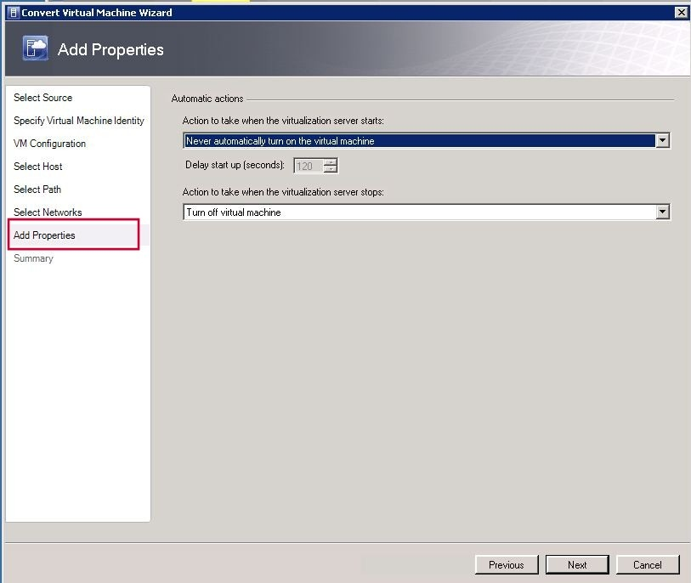
- On the Summary page, review the settings. Optionally, select the Start the virtual machine after deploying it check box. To start the conversion process, click Create. | 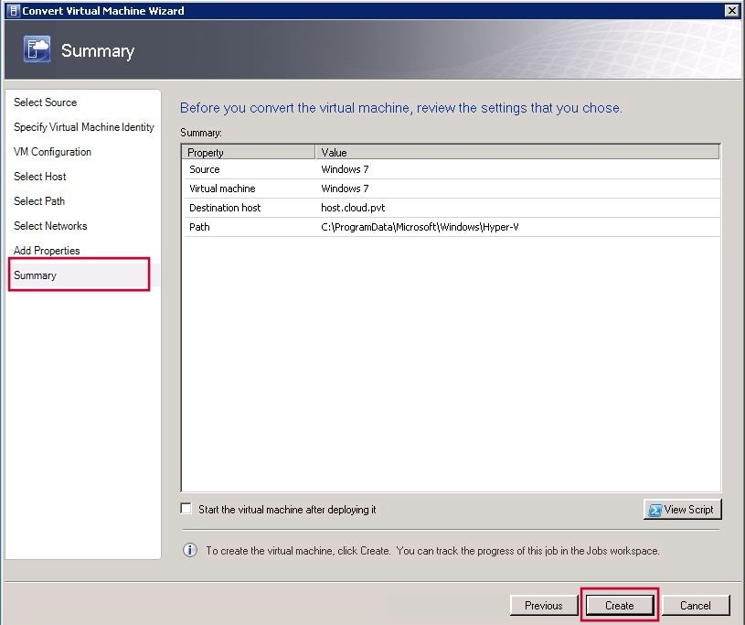
- Verify that the job has a status of Completed, and then close the dialog box. | 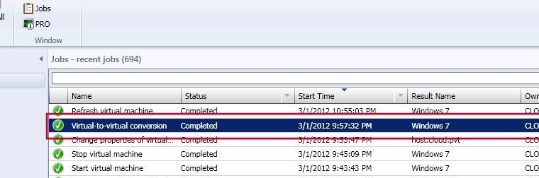
- To verify that the virtual machine was converted, do the following:  - In the VMs and Services workspace, locate and then click the Hyper-V host that you selected during placement.  - On the Home tab, in the Show group, click VMs.  - In the VMs pane, verify that the virtual machine appears. | 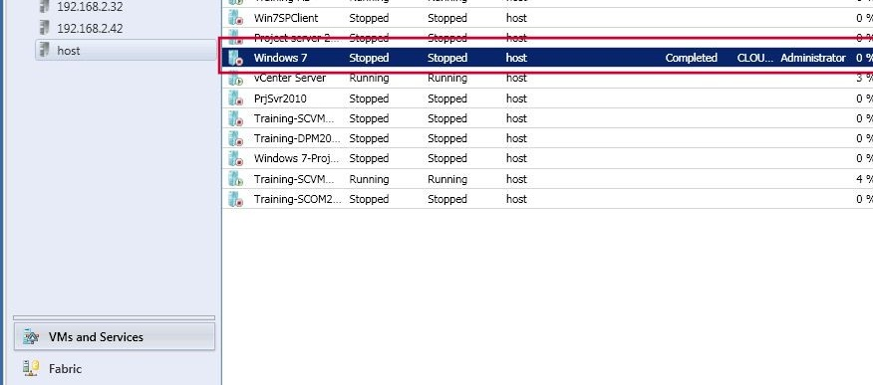

STEP 5: How to Create a Private Cloud from a VMware Resource Pool
STEPS | SCREENSHOTS
- Open the VMs and Services workspace. On the Home tab, in the Create group, click Create Cloud. | 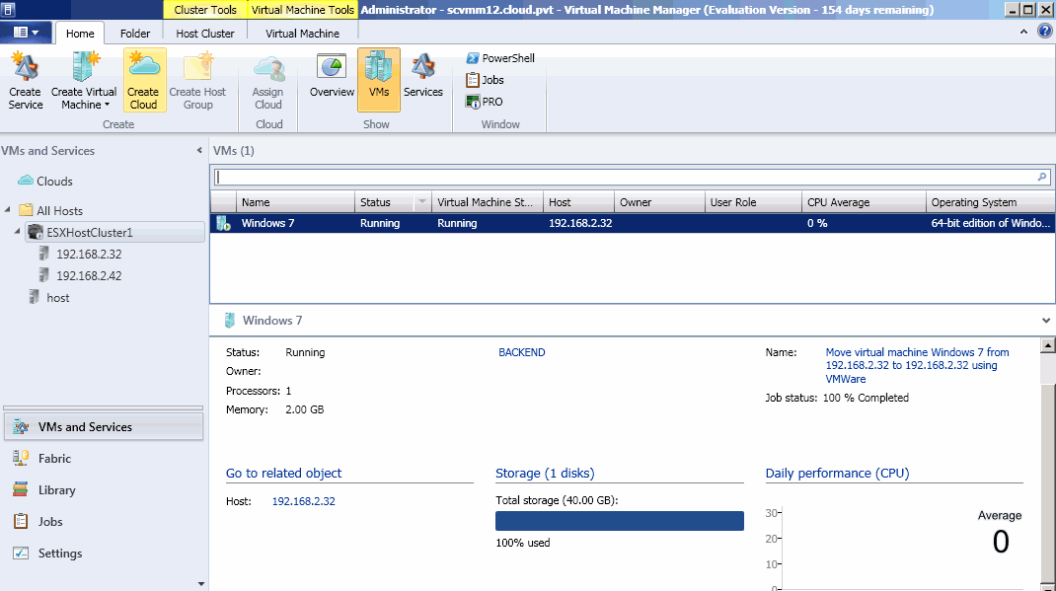
The Create Cloud Wizard opens.  - On the General page, enter a name and description for the private cloud, and then click Next. | 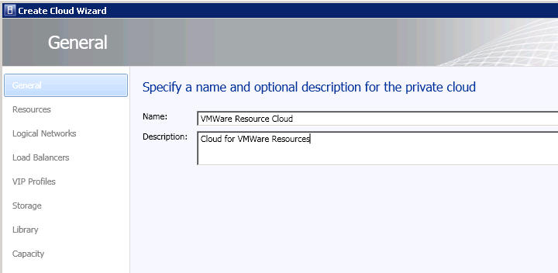
- On the Resources page, click VMware resource pools, select an available VMware resource pool, and then click Next. | 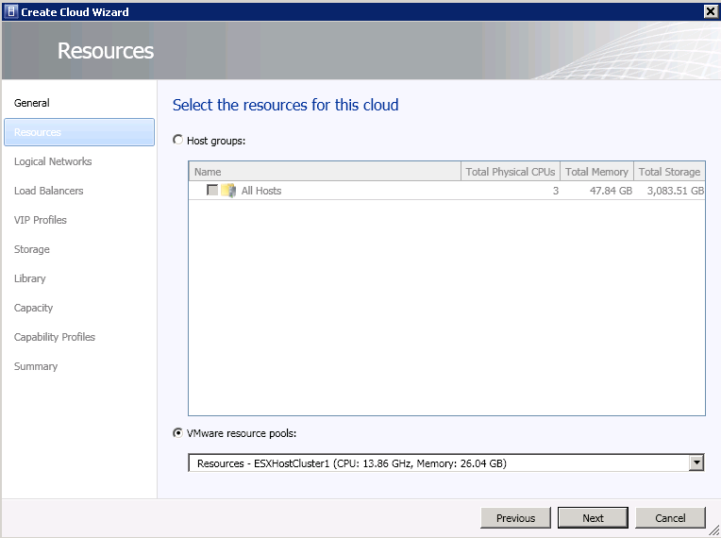
- On the Logical Networks page, select the check box next to each logical network that you want to make available to the private cloud, and then click Next. | 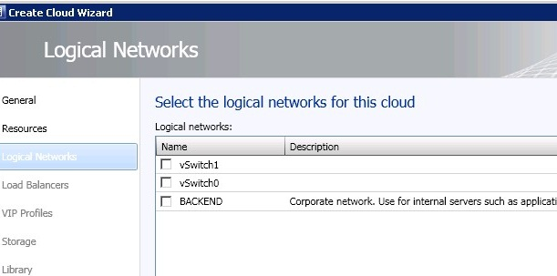
- On the Load Balancers page, select the check box next to each load balancer that you want to make available to the private cloud, and then click Next. | 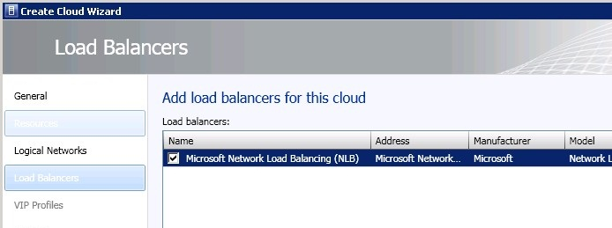
- On the VIP Profiles page, select the check box next to each VIP template that you want to make available to the private cloud, and then click Next. | 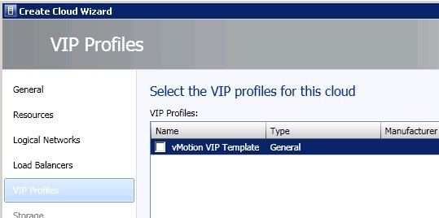
- On the Storage page, select from the already added storage pools from added classifications and click Next. We do not have a supported storage device added in this example. | 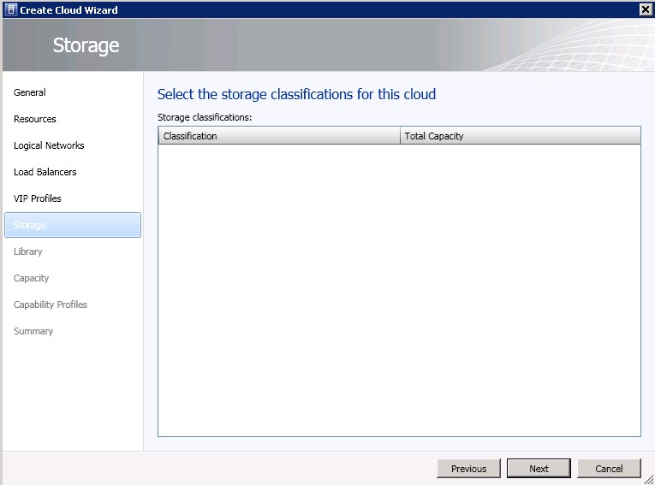
- On the Library page, do the following:  - Next to the Stored VM path box, click Browse. In the Select Destination Folder dialog box, expand the library server, click the library share or the folder in a library share that you want to use as the location for self-service users to store virtual machines, and then click OK.  - In the Read-only library shares area, click Add. Select the check box next to one or more library shares to use as the location where administrators can store read-only resources that they want to make available to self-service users, click OK, and then click Next. | 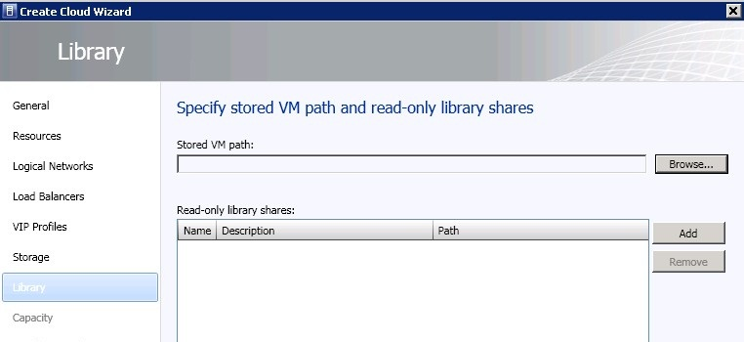  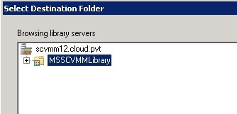  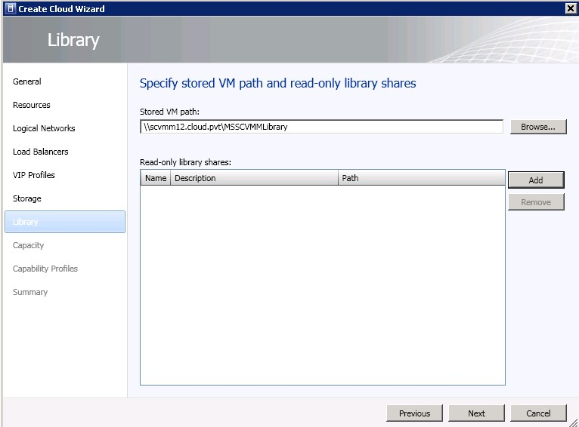
- On the Capacity page, set capacity limits for the private cloud, and then click Next. | 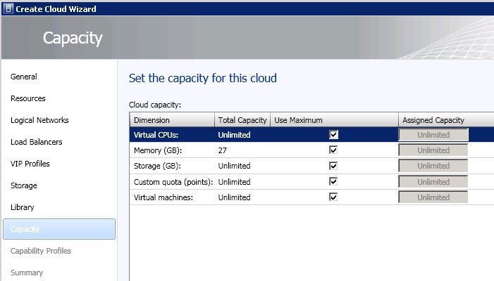
- The capacity limits shown above are assigned as unlimited. Howerver, the capacity limits can be customized for each cloud by deslecting the checkbox next to a particular cloud component and specifying the upper limit as shown in the example where the maximum number of virtual CPUs available for use in the cloud have been limited to 16. | 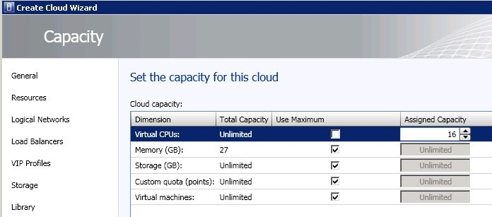
- On the Capability Profiles page, select the check box next to ESX Server, and then click Next. The built-in capability profiles represent the minimum and maximum values that can be configured for a virtual machine for each supported hypervisor platform. | 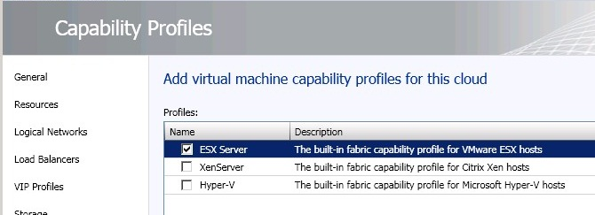
- On the Summary page, confirm the settings, and then click Finish. | 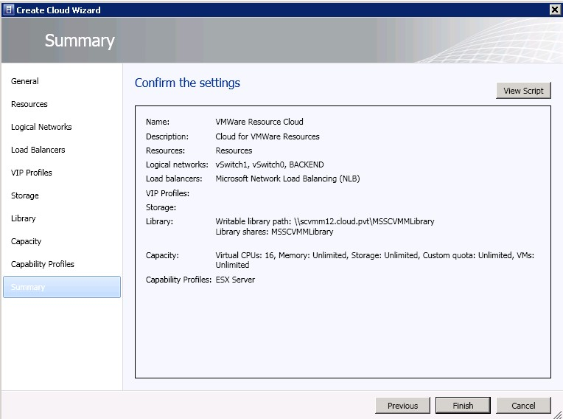
- To verify that the private cloud was created, in the VMs and Services workspace, expand Clouds. | 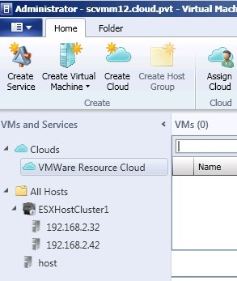

Scenario II: Automating your VMware Infrastructure using Orchestrator

Create a Sample Runbook Using Runbook Designer in Orchertrator
- Click on Start and select Runbook Designer. | 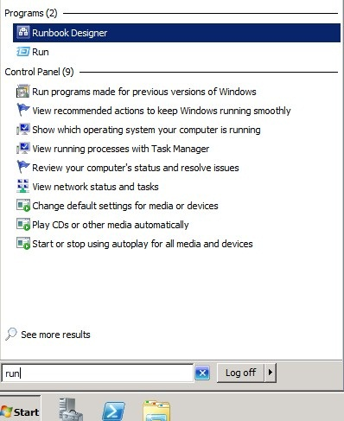
- Runbook Designer Opens. Click On Runbook Control and drag Initialize Data to Sample Runbook. | 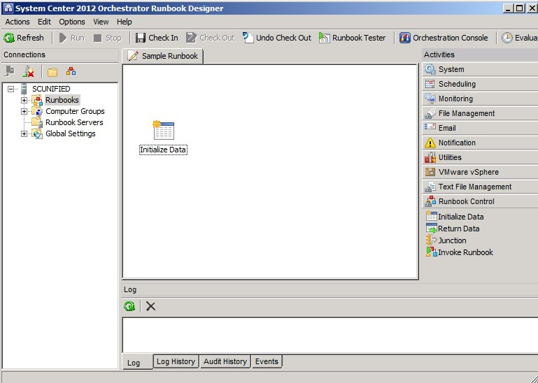
- Click on VMware vSphere and drag Get VM Status activity, Start VM activity, Stop VM activity and Clone Windows VM activity to Sample Runbook. | 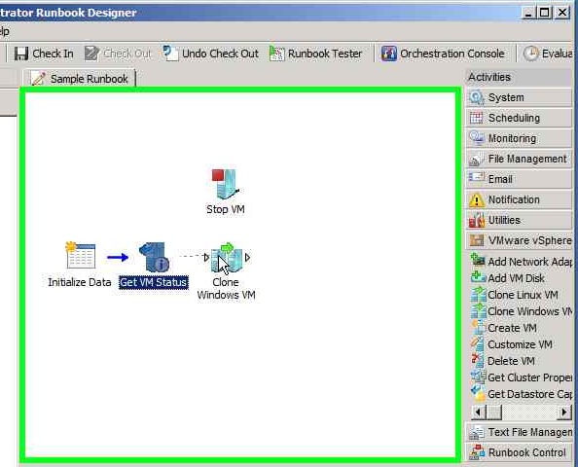
- Right click Initialize Data and select Properties. | 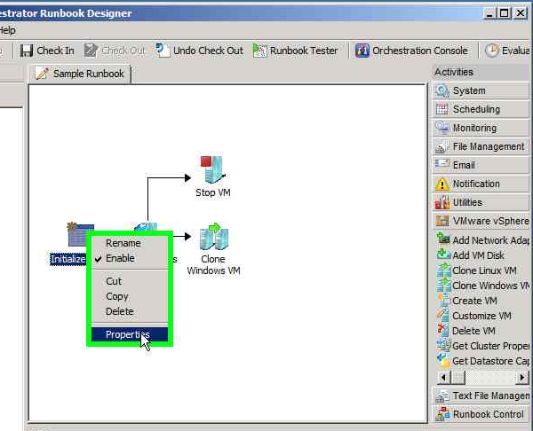
- Initialize Data Properties dialog box opens. In the Details Tab click Add to define the parameters to initialize activity. | 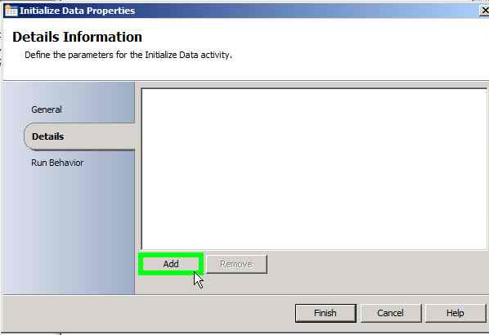
- Click on Parameter 1 and rename it as vCenterServer. | 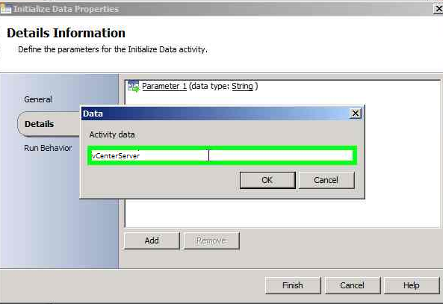
- Similarly add Username and Password Parameters and click Finish. | 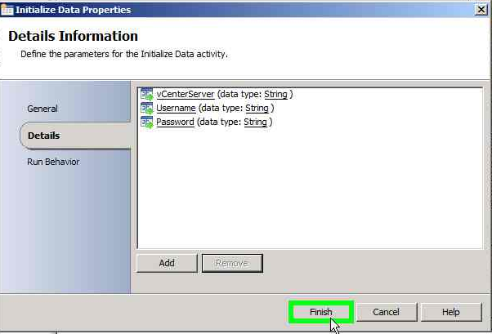
- Right click Get VM Status and select Properties. | 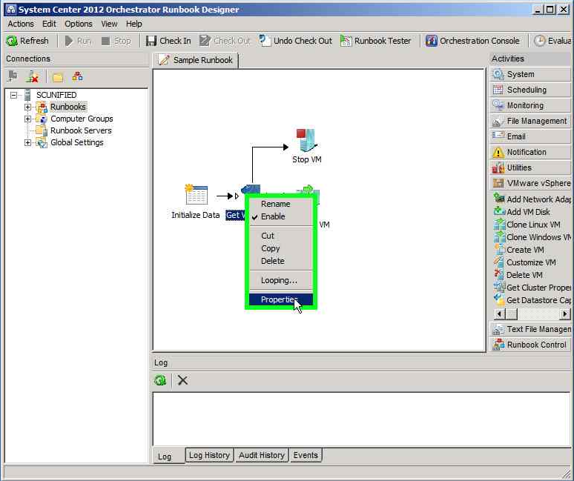
- Get VM Status Properties dialog box opens. Configure the settings in the Properties tab as follows:  - In the Configuration section, click the ellipsis button. Then select the VMware vSphere server connection that you want to use for this activity. Click Ok. | 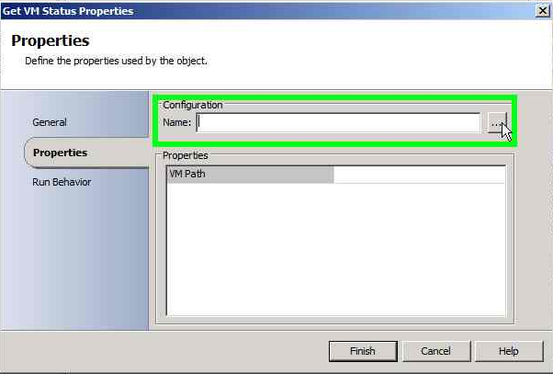
- In the Properties section, enter the value for each of the required properties and the applicable optional properties. If the property is lookup enabled, you can click the ellipsis button next to the text box to browse for a value. | 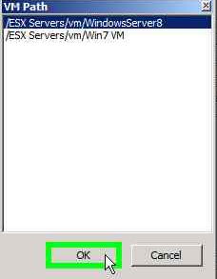
- Click Finish. | 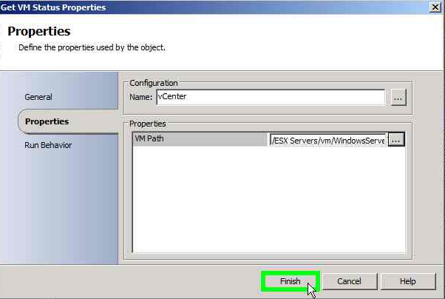
- Right click Stop VM and select Properties. | 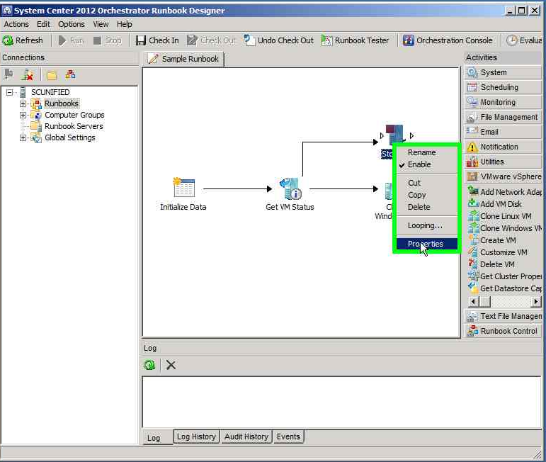
- Stop VM Properties dialog box opens. Configure the settings in the Properties tab as follows:  - In the Configuration section, click the ellipsis button. Then select the VMware vSphere server connection that you want to use for this activity. Click Ok. | 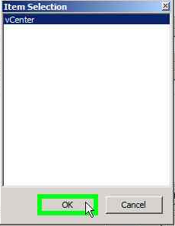
- In the Properties section, enter the value for each of the required properties and the applicable optional properties. If the property is lookup enabled, you can click the ellipsis button next to the text box to browse for a value. | 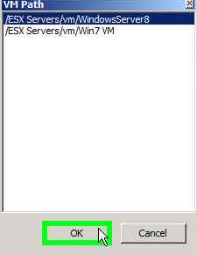
- Click Finish. | 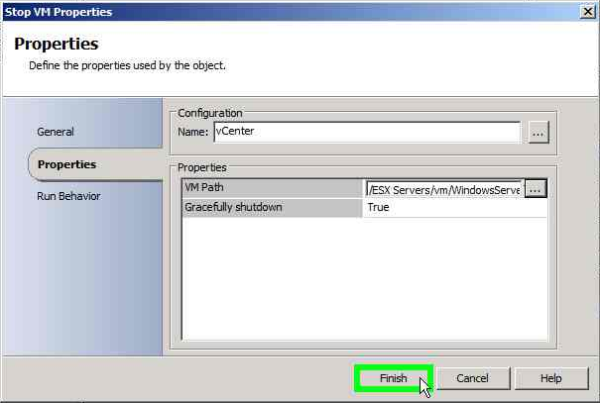
- Right click Clone Windows VM and select Properties. | 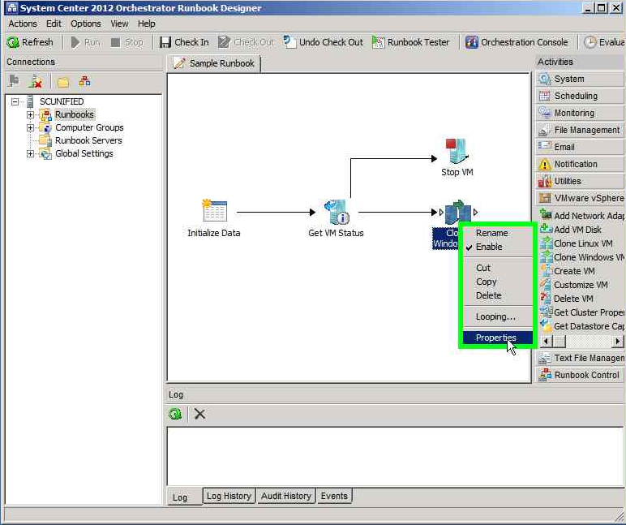
- Clone Windows VM Properties dialog box opens. Configure the settings in the Properties tab as follows:  - In the Configuration section, click the ellipsis button. Then select the VMware vSphere server connection that you want to use for this activity. Click Ok. | 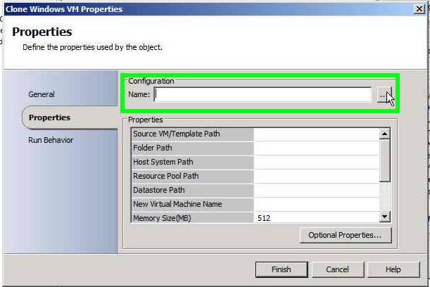
- In the Properties section, enter the value for each of the required properties and the applicable optional properties. If the property is lookup enabled, you can click the ellipsis button next to the text box to browse for a value. | 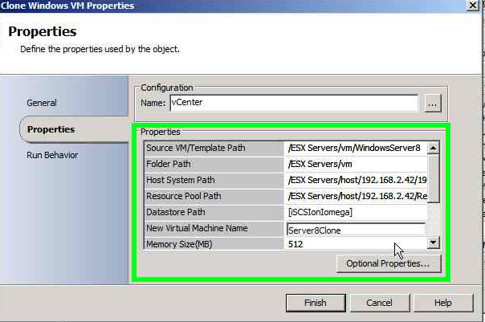
- Click Finish. | 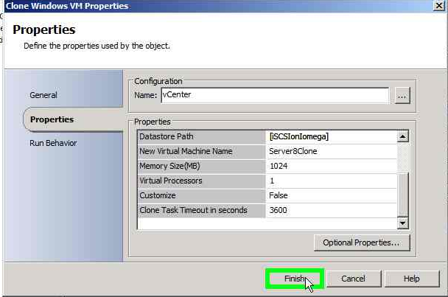
- Click on Runbook Tester. | 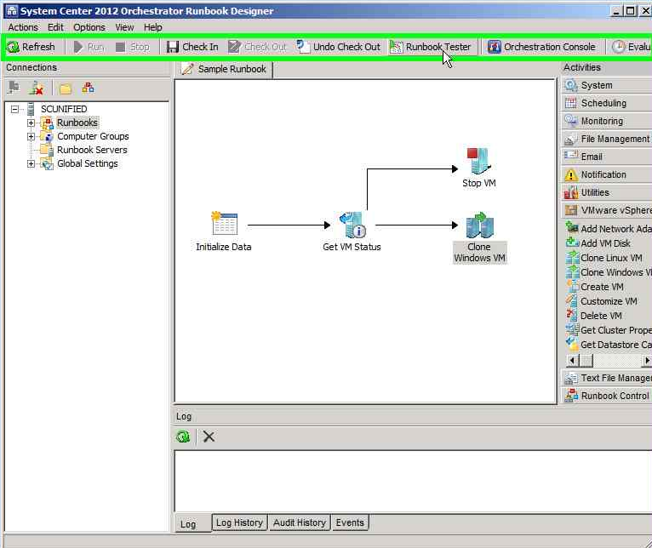
- Runbook Tester window opens. Click on Step through. | 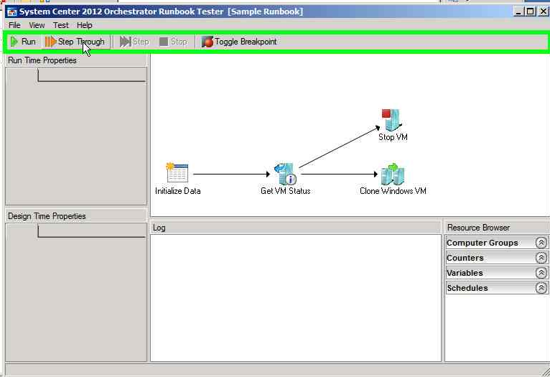
- In the Initialize Data Parameters dialog box, provide the parameters and click Ok. | 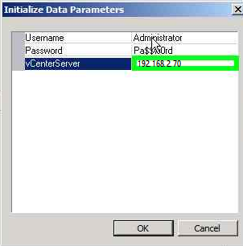
- Final result looks like this. | 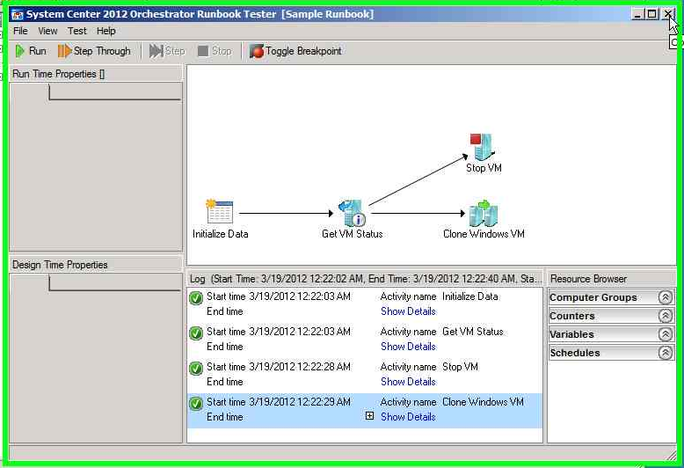

Scenario III: Monitoring your VMware Infrastructure using Operations Manager

I: Monitoring VMware Servers using Veeam nWorks Management Pack for System Center Operations Manager

STEPS | SCREENSHOTS
- To view the discovered VMware infrastructure in Operations Manager, open Monitoring workspace in the Operations Console. Expand nWorks VMware and click _vCenter Topology | 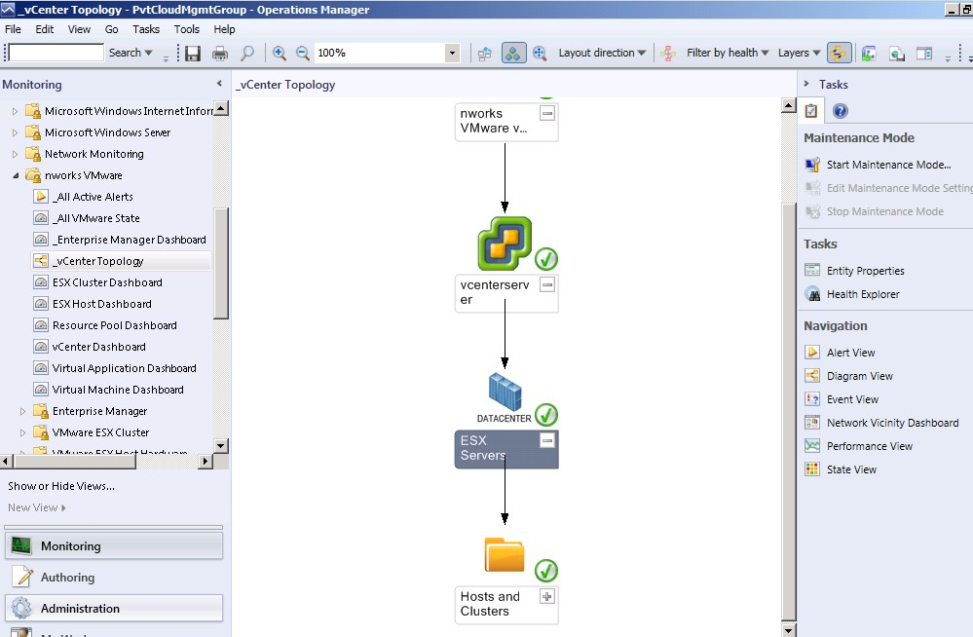
- Click Diagram View on Right | 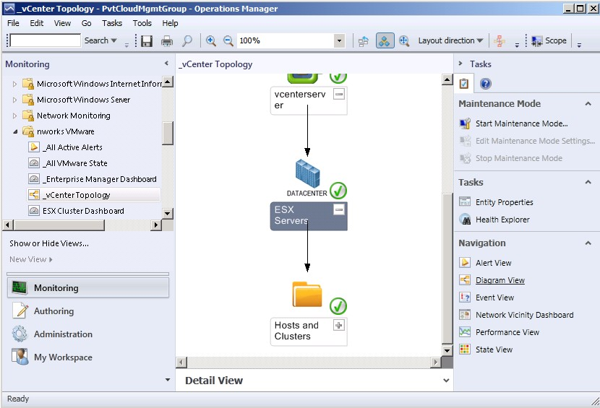
- The Diagram view of the discoved vCenter topology is displayed as shown: | 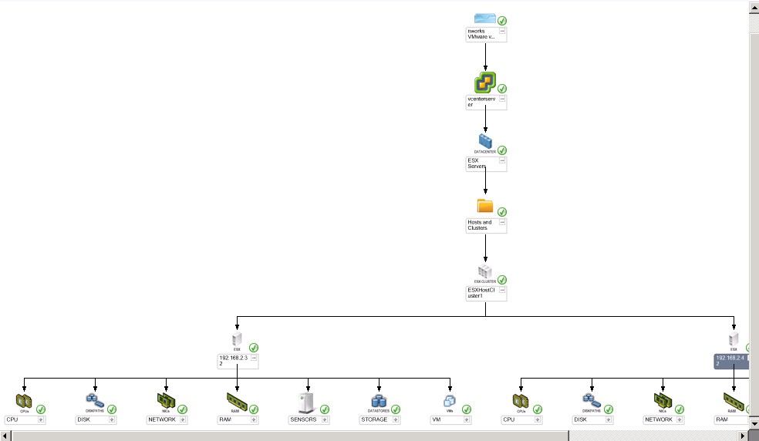
- You may click upon a component in the topology to see the details in the Details tab. For example the CP Details are shown here in the Detail View. | 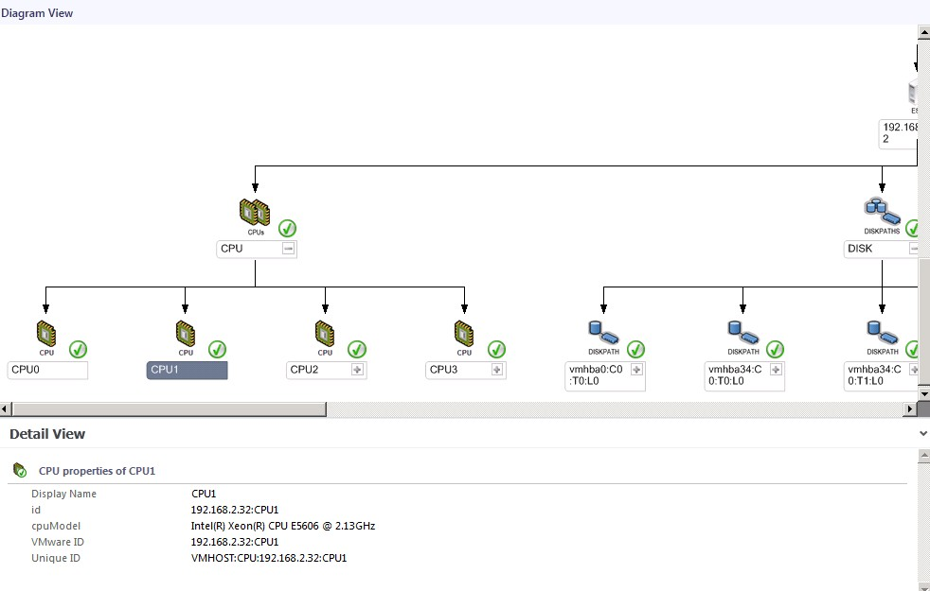
- The Disk details of an ESX host are shown here in the Details View when you select the Disk in the Diagram View. | 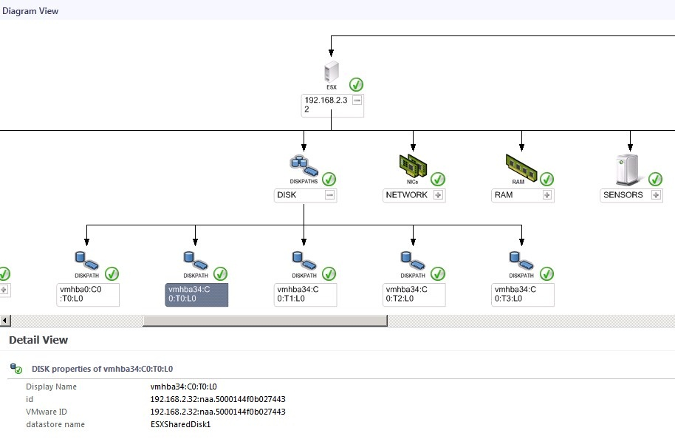
- NIC details are shown when an NIC is selected by expanding the NETWORK from the Diagram View. | 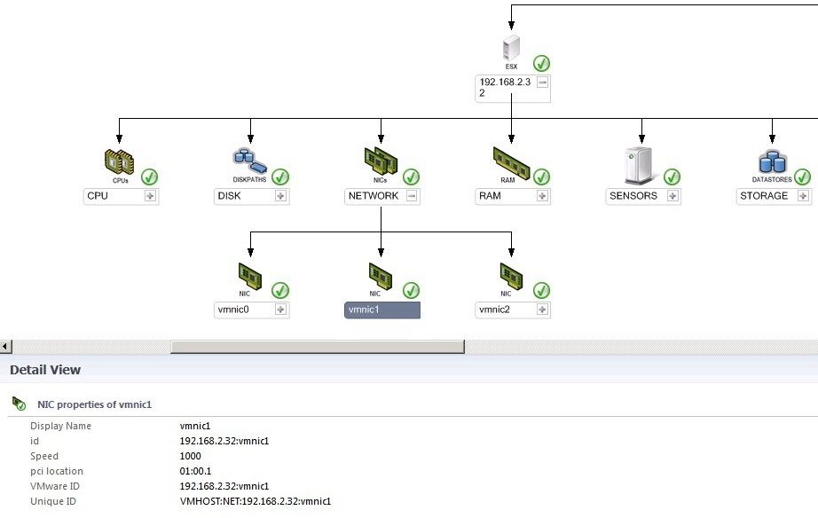
- The Hardware details of ESX Servers can be explored by expanding the components of the monitored ESX servers. | 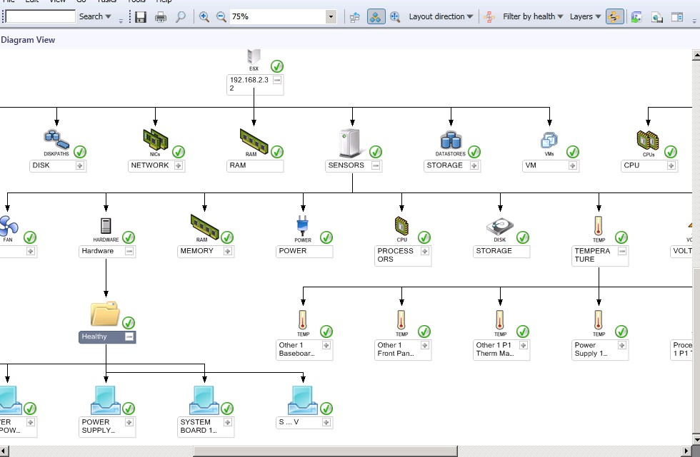
- The Virtual Machines hosted on an ESX server can also be seen by expanding the VM Component in the ESX server. | 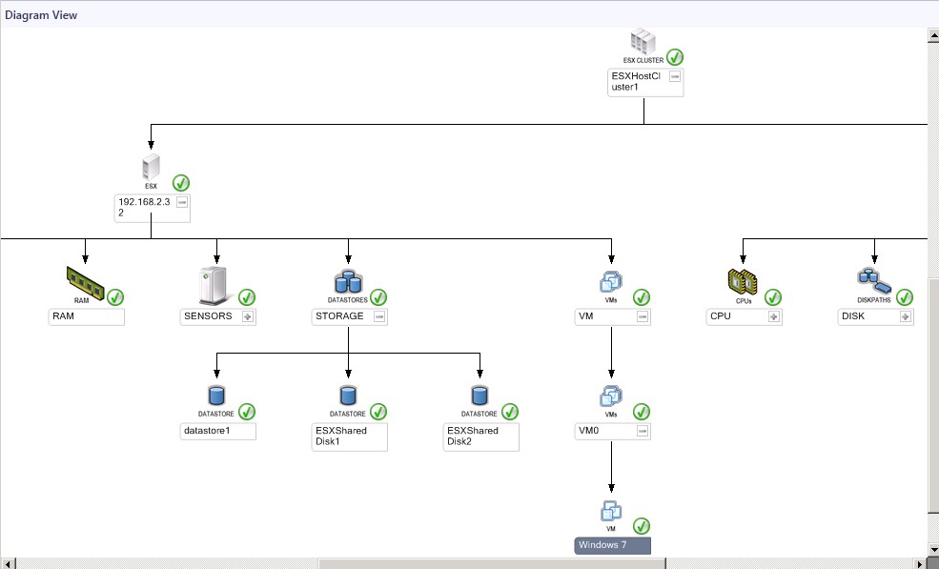
- Various ESX Host Tasks can be performed directly on the ESX hosts from the Oprations Manager server. For example the host can be put into and taken out of Maintenance Mode. | 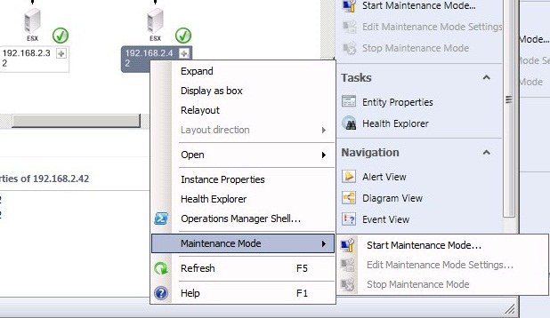
- To explore ESX Hosts state and any Active Alerts if present . Click ESX Host Dashboard from the nWorks VMWare list in the Monitoring worspakce. Various VMWare ESX Host Tasks like enterMaintenenceMode and exit MaintenanceMode can be performed directly from here. | 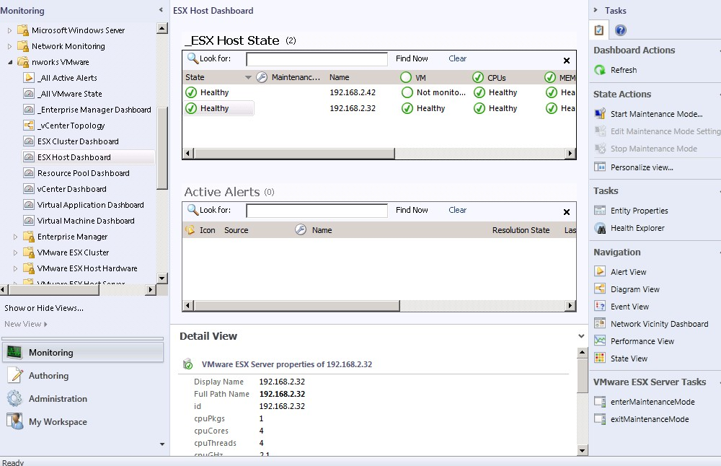
- Virtual Machine Dashboard can be explored to see the hosted Virtual Machines on the ESX servers and any Active Alerts if present. This dashboard also allows direct execution of VM related tasks from the Ops Mgr server itself from the VMGUEST Virtual Machine Tasks panel in the right. | 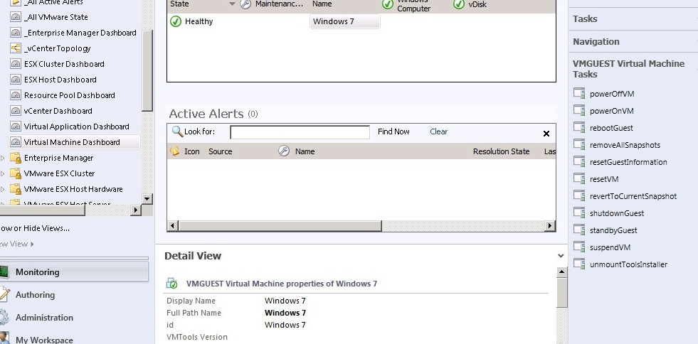
- The _AllVMWareState dashboard shows the overall state of the entire VMWare infrastructure including Cluster State, ESX Host State and VM State. | 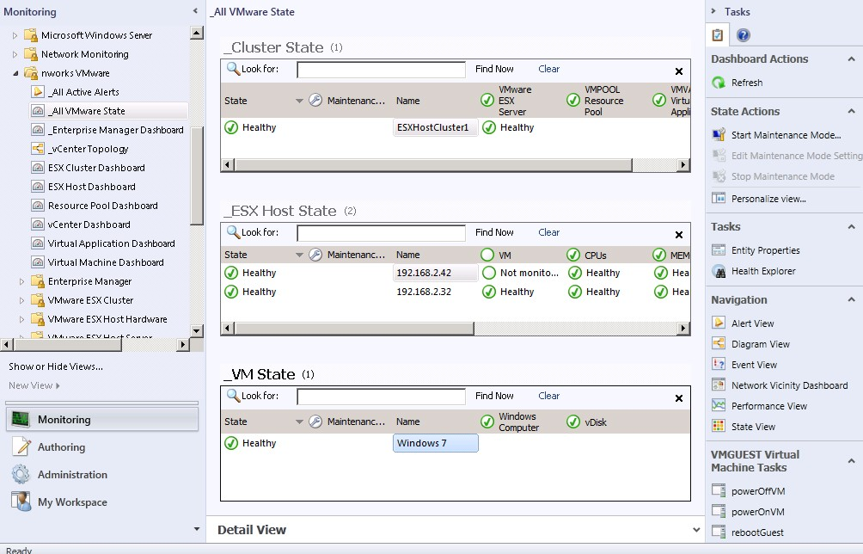
- Details of the cluster configuration can be seen in a Group Diagram of VMWare ESX Cluster. This also displays the combined capacity of the cluster. | 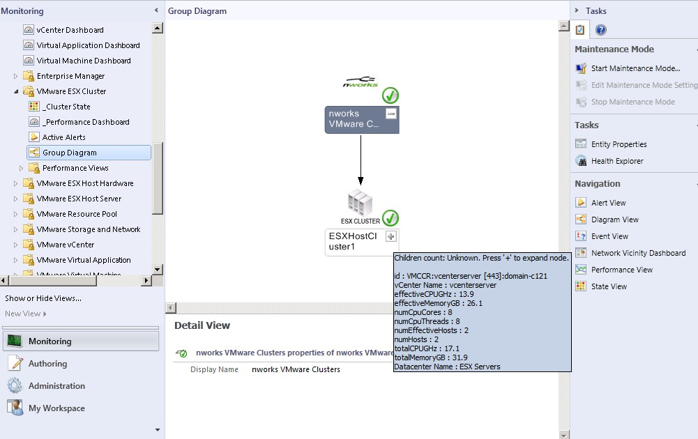
- Detailed information on the Cluster Performance can be gathered by expanding the Performance Views in the VMWare ESX Cluster list and clicking on All Cluster Performance. | 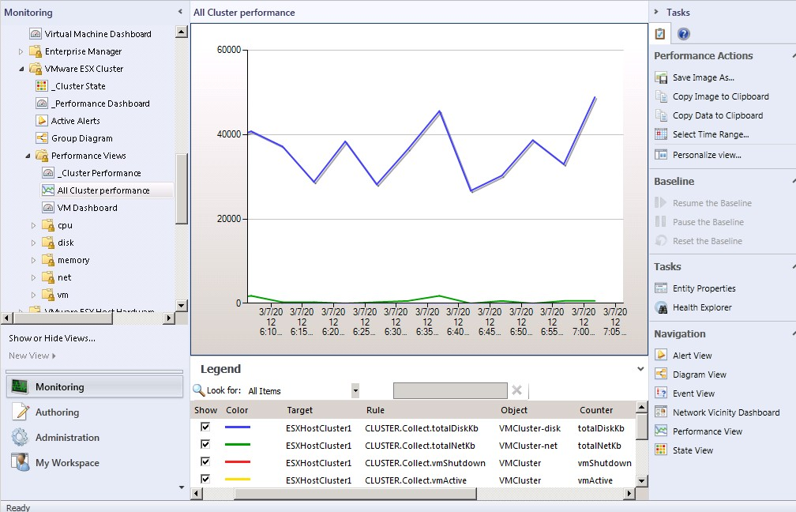
- Network specific monitoring data can be gathered by browsing through the net component in the Performance Views of VMWare ESX Cluster. | 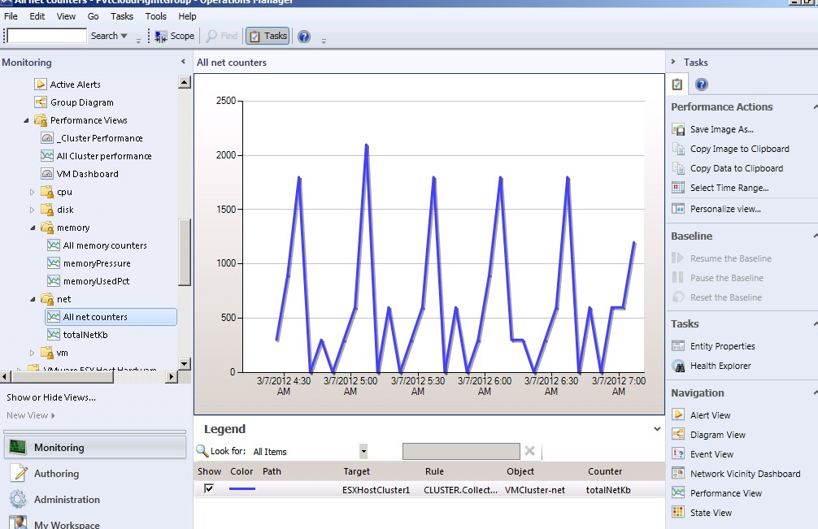
17. The Datastore details can be gathered from the Datastore Diagram view in the VMWare ESX Host Servers. | 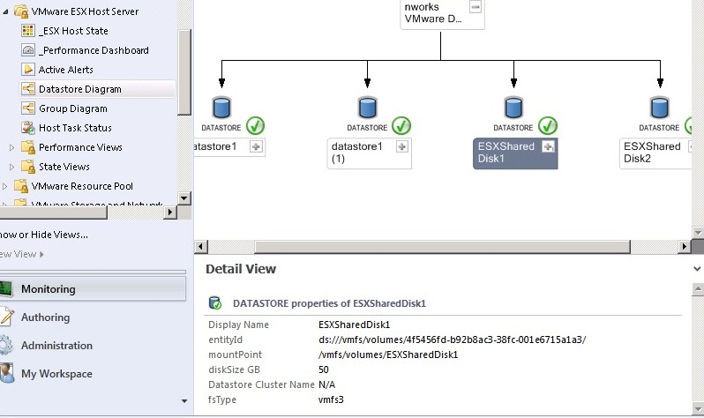
- ESX Host Servers Group Diagram displays ESX hosts monitored by nWorks Management Pack.  - Expand Performance Views under Virtual Machines Dashboard in the Monitoring Workspace. Click AllVMGuestPerformance. Check all counters from the Performance Counters tab. Notice the change in the CPUusage counter. | 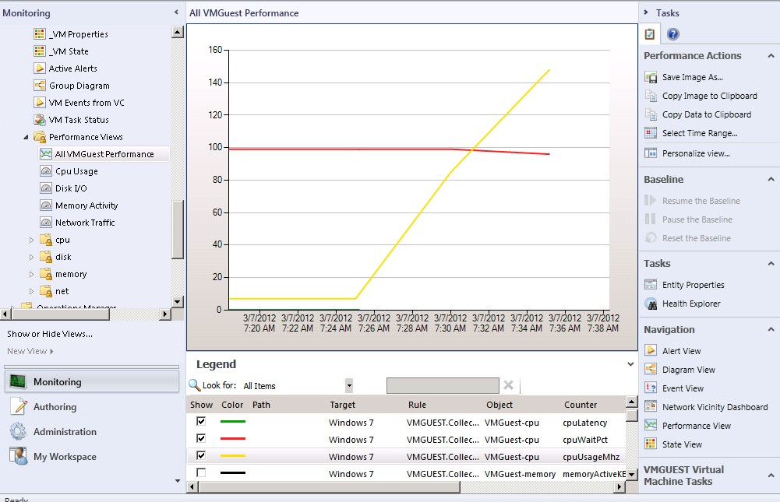
- After a few minutes of running the MaxCPU stress tool on the Windows 7 virtual machine, a Warning messege appears in the Active Alerts for the Virtual Machine. | 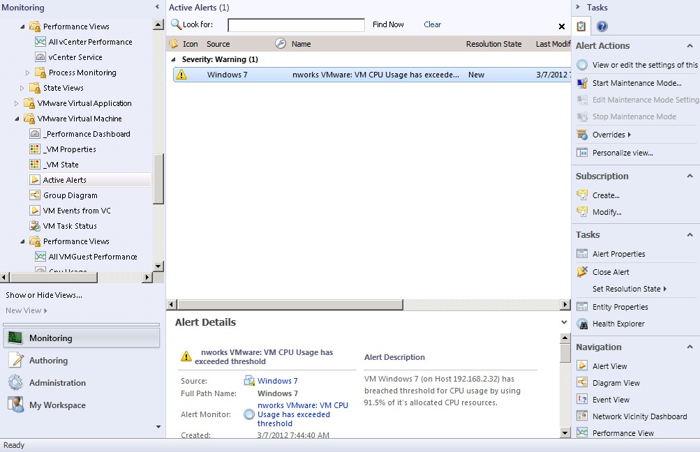
- After another few minutes of running MaxCPU stress tool continuously on the virtual machine, a critical alert appears in the Active Alerts for the virtual machine in the Operations Manager. | 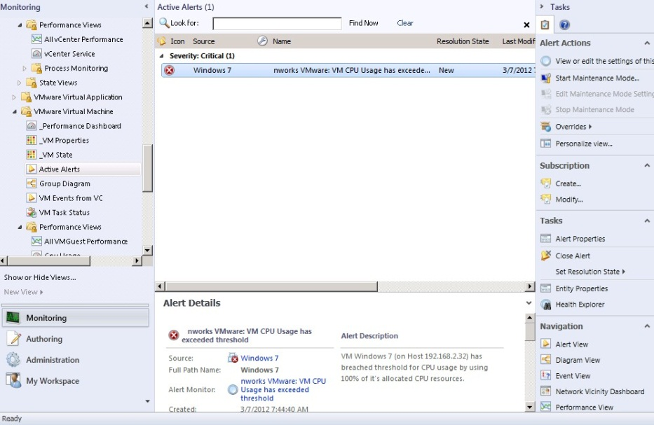
- The Alert Details can be seen in the Details Pane. | 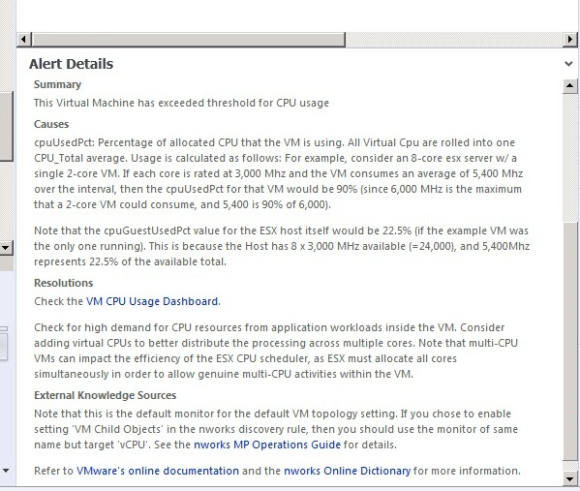

II: VMware Discovery and Monitoring with Bridgeways Management Pack in Operations Manager 2012 RC
Steps | Screenshots
- To see any active alerts in the discovered VMware infrastructure by Bridgeways Management Pack, click Monitoring | 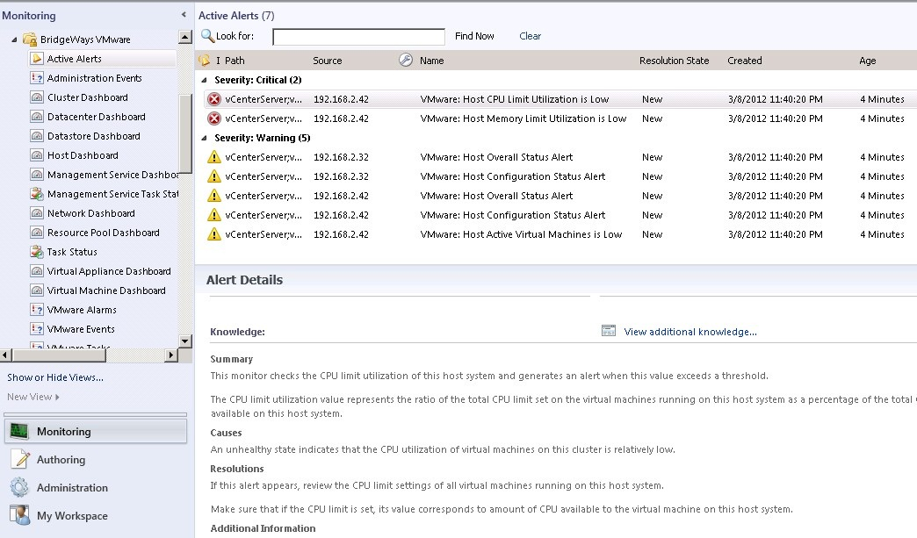
- Click View Additional Knowledge link to view more information on the Critical Alert. | 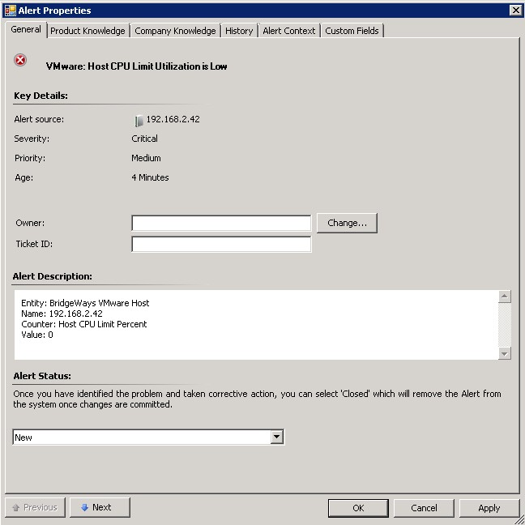
- Cluster information can be obtained by clicking the Cluster Dashboard. | 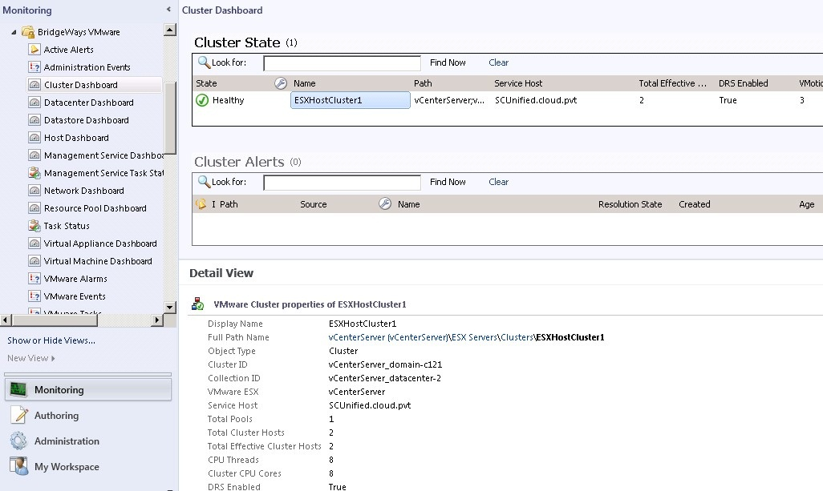
- The Right pane allows you to perform cluster related task right from within the cluster dashboard. | 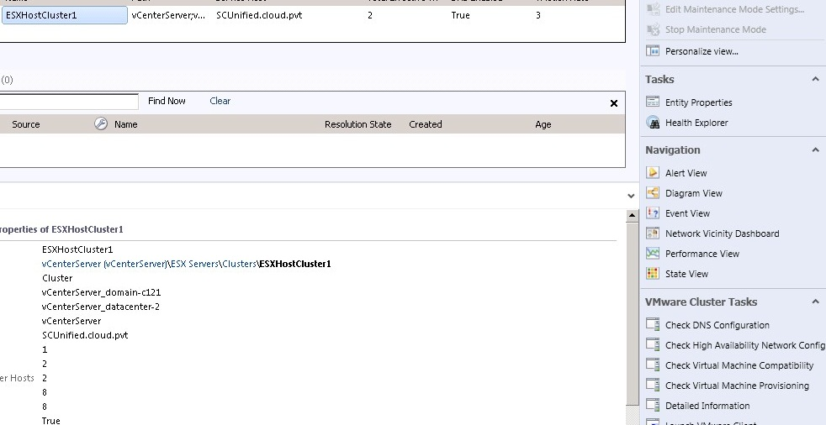
- Datastore Dashboard displays detailed datastore status and information. | 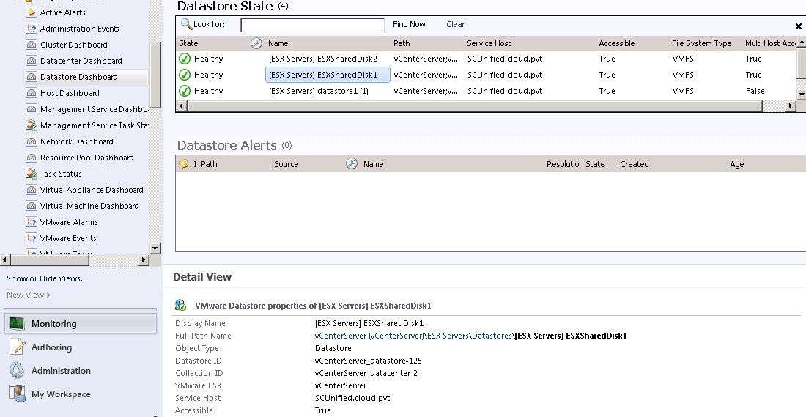
- Host Dashboard displays the active state of the hosts and detailed information in Hosts. | 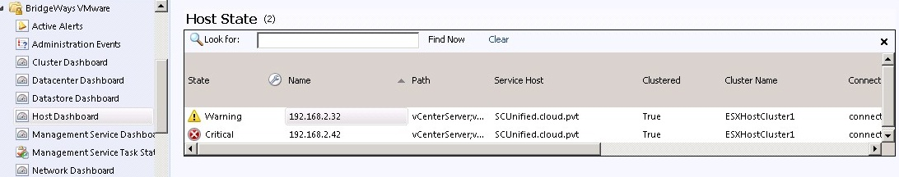
- Host specific Tasks like Enter Maintenance Mode, Exit Maintenance Mode and Generating a Diagnostic Bundle can be performed directly from the Operations Manager Task Pane. | 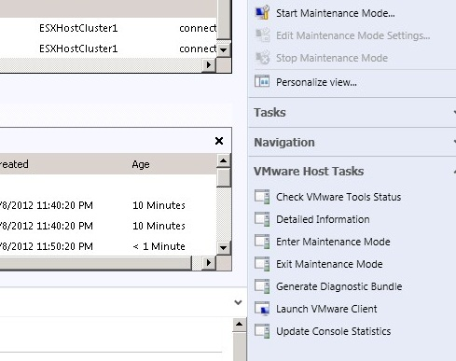
- The Virtual Machine Dashboard displays the health status of all virtual machines hosted on the monitored ESX servers. In this case the Dashboard displays an active critical alert for Windows 7 VM as a CPU stress tool was run on the virtual machine and the vCenter Server. Virtual machine specific tasks can be performed directly from the Tasks Pane in Operations Manager Console. | 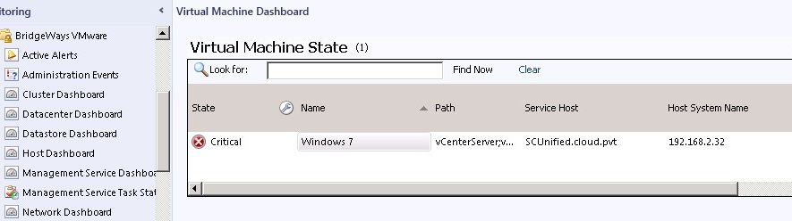

Official unofficial VMware storage survey, link here
Microsoft Private Cloud Economics Tool here

